A Course File
On
INFORMATION AND CYBER SECURITY LAB
(III- B. Tech. – I– Semester)
Submitted to
DEPARTMENT OF COMPUTER SCIENCE& ENGINEERING

By
Dr. S.ALAGUMUTHUKRISHNAN
(Assoc. Professor, Dept. of CSE)


CMR INSTITUTE OF TECHNOLOGY
(UGC AUTONOMOUS)
Kandlakoya(V), Medchal Road, Hyderabad – 501 401
Ph. No. 08418-222042, 22106 Fax No. 08418-222106

(2024-25)

CONTENTS

Sl. No. | Particulars | Page No.
1 | Syllabus | 3
2 | Course Outcomes | 6
3 | Mapping of Course with PEOs, POs | 6
4 | Mapping Of Course Outcomes with PEOs, POs | 6
5 | Direct Course Assessment | 7
6 | Indirect Course Assessment | 8
7 | Overall Course Assessment and Attainment level | 10
8 | Pi diagrams, Bar charts, Histograms for representing results | 11
9 | Lesson/Course Plan | 12
10 | Index | 13
11 | Week Programs | 27

INFORMATION AND CYBER SECURITY LAB
Course | B.Tech.-V-Sem. | L | T | P | C
Subject Code | 22-CS-PC-316 | - | - | 2 | 1

Course Outcomes (COs) & CO-PO Mapping (3-Strong; 2-Medium; 1-Weak Correlation)
COs | Upon completion of course the students will be able to | PO4 | PO5 | PO14
CO1 | explain concepts of cryptanalysis | 3 | 3 | 3
CO2 | Examine different vulnerability attacks | 3 | 3 | 3
CO3 | illustrate Wi-Fi security techniques | 3 | 3 | 3
CO4 | Able to do malware analysis. | 3 | 3 | 3
CO5 | Able to configure simple firewall and IT audit | 3 | 3 | 3

List of Experiments
Week | Title/Experiment
1 | Cryptanalysis of Caesar Cipher using Frequency Analysis
2 | Cryptanalysis of RSA
3 | Examination of a website to test the vulnerability of attacks. – DVWA setup & SQLi
4 | Examination of a website to test the vulnerability of attacks. – XSS & CSRF & Command line injection attack
5 | Implement Firewall for an organization.
6 | Implement Wi-Fi security (WPA2, IP based, MAC Based)
7 | Analyze and exploit the root system of CMROS
8 | Implementing and analyzing target using metasploit and gain control over the system
9 | Implementation of IT Audit, malware analysis and Vulnerability assessment and generate the report
10 | Test security of UPI applications on Desktop sharing applications.
References
              - Information and Cyber Security Lab Manual, Department of CSE, CMRIT, Hyd.

CMR INSTITUTE OF TECHNOLOGY
VISION: To create world class technocrats for societal needs
MISSION: Impart global quality technical education for a better future by providing appropriate learning environment through continuous improvement and customization
QUALITY POLICY: Strive for global excellence in academics and research to the satisfaction of students and stakeholders
DEPARTMENT OF COMPUTER SCIENCE AND ENGINEERING (CSE)

Vision:To be a model for academic excellence and research in the field of computer science and engineering that prepares competent professionals with innovative skills, moral values and societal concern.

Mission: Impart quality education through state-of-art curriculum, conductive learning environment and research with scope for continuous improvement leading to overall professional success.
I. PROGRAMME EDUCATIONAL OBJECTIVES (PEO’s)

PEO1:Graduate will be capable of practicing principles of computer science & engineering, mathematics and scientific investigation to solve the problems that are appropriate to the discipline. [PO1, PO2, PO3]
PEO2: Graduate will be an efficient software engineer in diverse fields and will be a successful professional and/or pursue higher education and research. [PO4, PO5, PO6, PO8, PO9, PO11]
PEO3: Graduate exhibits professional ethics, communication skills, teamwork and adapts to changing environments of engineering and technology by engaging in lifelong learning. [PO7, PO8, PO9, PO10, PO12]

II. PROGRAMME OUTCOMES (PO’s)

1. Engineering knowledge: Apply the knowledge of mathematics, science, engineering fundamentals, and an engineering specialization to the solution of complex engineering problems. [PEO’s: 1,2 and 3]
2. Problem analysis: Identify, formulate, review research literature, and analyze complex engineering problems reaching substantiated conclusions using first principles of mathematics, natural sciences, and engineering sciences. [PEO’s: 1,2 and 3]
3. Design/development of solutions: Design solutions for complex engineering problems and design system components or processes that meet the specified needs with appropriate consideration for the public health and safety, and the cultural, societal, and environmental considerations. [PEO’s: 1,2 and 3]
4. Conduct investigations of complex problems: Use research-based knowledge and research methods including design of experiments, analysis and interpretation of data, and synthesis of the information to provide valid conclusions. [PEO’s: 1,2 and 3]
5. Modern tool usage: Create, select, and apply appropriate techniques, resources, and modern engineering and IT tools including prediction and modeling to complex engineering activities with an understanding of the limitations. [PEO’s: 1,2 and 3]
6. The engineer and society: Apply reasoning informed by the contextual knowledge to assess societal, health, safety, legal and cultural issues and the consequent responsibilities relevant to the professional engineering practice. [PEO’s: 2 and 3]
7. Environment and sustainability: Understand the impact of the professional engineering solutions in societal and environmental contexts, and demonstrate the knowledge of, and need for sustainable development. [PEO’s: 1,2 and 3]
8. Ethics: Apply ethical principles and commit to professional ethics and responsibilities and norms of the engineering practice. [PEO’s: 1,2 and 3]
9. Individual and team work: Function effectively as an individual, and as a member or leader in diverse teams, and in multidisciplinary settings. [PEO’s: 1,2 and 3]
10. Communication: Communicate effectively on complex engineering activities with the engineering community and with society at large, such as, being able to comprehend and write effective reports and design documentation, make effective presentations, and give and receive clear instructions. [PEO’s: 1,2 and 3]
11. Project management and finance: Demonstrate knowledge and understanding of the engineering and management principles and apply these to one’s own work, as a member and leader in a team, to manage projects and in multidisciplinary environments. [PEO’s: 1 and 3]
12. Life-long learning: Recognize the need for, and have the preparation and ability to engage in independent and life-long learning in the broadest context of technological change. [PEO’s: 1,2 and 3]

III. COURSE OUTCOMES

COs | Upon completion of course the students will be able to | PO4 | PO5 | PO14
CO1 | explain concepts of cryptanalysis | 3 | 3 | 3
CO2 | Examine different vulnerability attacks | 3 | 3 | 3
CO3 | illustrate Wi-Fi security techniques | 3 | 3 | 3
CO4 | Able to do malware analysis. | 3 | 3 | 3
CO5 | Able to configure simple firewall and IT audit | 3 | 3 | 3

IV. COURSE MAPPING WITH PEO’S, PO’S
(No correlation: 0; Low: 1; Medium: 2; High: 3)
Course Title | PEO1 | PEO2 | PEO3 | PO1 | PO2 | PO3 | PO4 | PO5 | PO6 | PO7 | PO8 | PO9 | PO10 | PO11 | PO12
OOP through JAVA Lab |  | 3 |  | - | - | - | 3 | 3 | - | - | - | - | - | - | -

V. MAPPING OF COURSE OUTCOMES WITH PEO’S, PO’S
(No correlation: 0; Low: 1; Medium: 2; High: 3)
Course Outcomes | PEO1 | PEO2 | PEO3 | PO1 | PO2 | PO3 | PO4 | PO5 | PO6 | PO7 | PO8 | PO9 | PO10 | PO11 | PO12
CO - 1 | - | 3 | - | - | - | - | 3 | 3 | - | - | - | - | - | - | -
CO – 2 | - | 3 | - | - | - | - | 3 | 3 | - | - | - | - | - | - | -
CO – 3 | - | 3 | - | - | - | - | 3 | 3 | - | - | - | - | - | - | -
CO – 4 | - | 3 | - | - | - | - | 3 | 3 | - | - | - | - | - | - | -
CO – 5 | - | 3 | - | - | - | - | 3 | 3 | - | - | - | - | - | - | -

Direct Course Assessment

(As mentioned in following table of 10 parameters, of which consider only the parameters required for this courses)
No | Description | Targeted Performance | Actual Performance | Remarks | Course Attainment
1 | Internal Marks(25) | 80% of Students(192 Students) should Secure 60% of Internal Marks i.e., 15 Marks | NA | All Course Outcomes in general attained & Marks Awarded or Attainment Level is 3(Strong & High) | NA
2 | External Marks(50) | 60% of Students(144 Students) should Secure 70% of External Marks i.e., 35 Marks | NA | All the Course Outcomes in general attained & Marks Awarded or Attainment Level is 3(Strong & High) | NA
3 | Clearing of Subject | A minimum of 90% of Students(216 Students) should clear this course in first attempt | NA | All Course Outcomes in general attained & Marks Awarded or Attainment Level is 3(Strong & High) | NA
4 | Getting First Class | 80% of Students(192 Students) should Secure I Class Marks i.e., 45 Marks in my course | NA | All Course Outcomes in general attained & Marks Awarded or Attainment Level is 3(Strong & High) | NA
5 | Distinction | 70% of Students (168 Students) should secure First Class With Distinction i.e., 53 Marks in my course | NA | All the Course Outcomes in general attained & Marks Awarded or Attainment Level is 1.5M(Low) | NA
6 | Outstanding Performance | 60% of Students (144 Students) should secure 80% and above Marks.i.e., 60 Marks in my course | NA | All the Course Outcomes in general attained & Marks Awarded or Attainment Level is 1.5M(Low) | NA

Indirect Course Assessment

(As mentioned-strong (3), moderate (2), weak (1) & no comment (0))

Mission Statement of CSE
- Impart fundamentals through state of art technologies for research and career in Computer Science & Engineering.
- Create value-based, socially committed professionals for anticipating and satisfyingfast changing societal requirements.
- Foster continuous self learning abilities through regular interaction with various stake holders for holistic development.

Correlation of Mission Elements with Mission Statement of CSE Department related to the Course (only Ticking given by faculty)

No | Mission Elements | Strong | Moderate | Weak | No Comment
M-1 | Impart Fundamentals | √
M-2 | State Of Art Technologies | √
M-3 | Research & Career Development | √
M-4 | Value based Socially Committed Professional | √
M-5 | Anticipating & Satisfying Industry Trends |  | √
M-6 | Changing Societal Requirements |  | √
M-7 | Foster Continuous Learning | √
M-8 | Self Learning Abilities | √
M-9 | Interaction with stakeholders | √
M-10 | Holistic Development | √

Indirect Course Assessment through Student Satisfaction Survey
(Note for *:Parameters used for course teaching like
a: Classroom teaching b: Simulations c:labs d: Mini_Projects
e: Major Projects f: Conferences g: professional activities
h: Technical Clubs i: Guest Lectures j: Workshopsk: Technical Festsl:Tutorials m:NPTLs n:Digital Library o: Industrial Visits
p: software Tools q: Internship/training r:Technical Seminars
s: NSS t: NSS u: sports etc.
Further assume other parameters if any)

No | Question Based on PEO/PO/PSO/CO | Parameters  (a /b /c…/)* | Strong (3) | Moderate (2) | Weak (1) | No comment (0)
1 | Did the course impart fundamentals through interactive learning and contribute to core competence? | a,b,c,d,e,h,i,l,m,p,q
2 | Did the course provide the required knowledge to foster continuous learning? | a,b,c,d,e,h,i,l,m,p,q
3 | Whether the syllabus content anticipates & satisfies the industry and societal needs? | a,b,c,d,e,h,i,l,m,p,q
4 | Whether the course focuses on value based education to be a socially committed professional? | a,b,c,d,e,h,i,l,m,p,q
5 | Rate the role of the facilitator in mentoring and promoting the self learning abilities to excel academically and professionally? | a,b,c,d,e,h,i,l,m,p,q
6 | Rate the methodology adopted and techniques used in teaching learning processes? | a,b,c,d,e,h,i,l,m,p,q
7 | Rate the course in applying sciences & engineering fundamentals in providing research based conclusions with the help of modern tools? | a,b,c,d,e,h,i,l,m,p,q
8 | Did the course have any scope to design, develop and test a system or component? | a,b,c,d,e,h,i,l,m,p,q
9 | Rate the scope of this course in addressing cultural, legal, health, environment and safety issues? | a,b,c,d,e,h,i,l,m,p,q
10 | Scope of applying management fundamentals to demonstrate effective technical project presentations & report writing? | a,b,c,d,e,h,i,l,m,p,q
Total
Average

Overall Course Assessment

(80% Direct + 20% Indirect, if any)

No | Assessment Type | Weightage | Attainment Level
1 | Direct-Assignment, Quiz, Subjective, University Exams, Results, Bench Marks
2 | Indirect-Surveys-Questionnaire
 | Overall

Course Attainment level:

INFORMATION AND CYBER SECURITY LAB Course:

Pi diagrams, Bar charts, Histograms

(For representing previous results, if any)

Information and Cyber security Lab Pass % for Last 3 Academic Years | Appeared | Passed | Pass%
2022-23

Lesson/Course Plan
Week No. | Name of the Program | No. of Lab sessions | Text Books | Mode of Assessment
1 | Cryptanalysis of Caesar Cipher using Frequency Analysis | 1 | T1 | Viva&Execution
2 | Cryptanalysis of RSA | 1 | T1 | Viva&Execution
3 | Examination of a website to test the vulnerability of attacks. – DVWA setup & SQLi | 1 | T1 | Viva&Execution
4 | Examination of a website to test the vulnerability of attacks. – XSS & CSRF & Command line injection attack | 1 | T1 | Viva&Execution
5 | Implement Firewall for an organization. | 1 | T1 | Viva&Execution
6 | Implement Wi-Fi security (WPA2, IP based, MAC Based) | 1 | T1 | Viva&Execution
7 | Analyze and exploit the root system of CMROS | 1 | T1 | Viva&Execution
8 | Implementing and analyzing target using metasploit and gain control over the system | 1 | T1 | Viva&Execution
9 | Implementation of IT Audit, malware analysis and Vulnerability assessment and generate the report | 1 | T1 | Viva&Execution
10 | Test security of UPI applications on Desktop sharing applications. | 1 | T1 | Viva&Execution
 | Total no of Lab sessions required to complete syllabus | 10

Installing VMware and Kali Linux

Downloading VMware Workstation
TodownloadVMwareWorkstation:
Navigate to the VMware Workstation Download Center.
- Based on your requirements, click Go to Downloads for VMware Workstation for Windows or VMware Workstation for Linux.
- Click Download Now.
- If prompted, log in to your Customer Connect profile. If you do not have a profile, create one. For more information, see How to create a Customer Connect profile (2007005).
- Ensure that your profile is complete and enter all mandatory fields. For more information, see How to update your Customer Connect profile (2086266).
- Review the End User License Agreement and click Yes.
- Click Download Now.
If the installer fails to download during the download process:
- Delete the cache in your web browser. For more information, see:
  - Mozilla Firefox: How to clear the Firefox cache
  - Google Chrome: Delete your cache and other browser data
  - Microsoft Internet Explorer: How to delete the contents of the Temporary Internet Files folder
- Disable the pop-up blocker in your web browser. For more information, see:
  - Mozilla Firefox: How do I disable a Pop-up blocker?
  - Google Chrome: Manage pop-ups
  - Microsoft Internet Explorer: How to turn Internet Explorer Pop-up Blocker on or off on a Windows XP SP2-based computer
- Download using a different web browser application.
- Disable any local firewall software.
- Restart the virtual machine.
- Download the installer from a different computer or network.

Installing VMware Workstation
Notes:
- You must have only one VMware Workstation installed at a time. You must uninstall the previous version of VMware Workstation before installing a new version.
- If the installer reports an error when you run it, you must verify the download. For more information, see Verifying the integrity of downloaded installer files (1537).
To install VMware Workstation on a Windows host:
- Log in to the Windows host system as the Administrator user or as a user who is a member of the local Administrators group.
- Open the folder where the VMware Workstation installer was downloaded. The default location is the Downloads folder for the user account on the Windows host.
Note: The installer file name is similar to VMware-workstation-full-xxxx-xxxx.exe, where xxxx-xxxx is the version and build numbers.
- Right-click the installer and click Run as Administrator.
- Select a setup option:
  - Typical: Installs typical Workstation features. If the Integrated Virtual Debugger for Visual Studio or Eclipse is present on the host system, the associated Workstation plug-ins are installed.
  - Custom: This lets you select which Workstation features to install and specify where to install them. Select this option if you need to change the shared virtual machines directory, modify the VMware Workstation Server port, or install the enhanced virtual keyboard driver. The enhanced virtual keyboard driver provides better handling of international keyboards and keyboards that have extra keys.
- Follow the on-screen instructions to finish the installation.
- Restart the host machine.
To install VMware Workstation on a Linux host:
Note: VMware Workstation for Linux is available as a .bundle download in the VMware Download Center. The Linux bundle installer starts a GUI wizard on most Linux distributions. In some Linux distributions, the bundle installer starts a command-line wizard instead of a GUI wizard.
- Log in to the Linux host with the user account that you plan to use with VMware Workstation.
- Open a terminal interface. For more information, see Opening a command or shell prompt (1003892).
- Change to root. For example:
su root
Note: The command that you use depends on your Linux distribution and configuration.
- Change directories to the directory that contains the VMware Workstation bundle installer file. The default location is the Download directory.
- Run the appropriate Workstation installer file for the host system.

Kali Linux - Installation and Configuration

Kali Linux is one of the best security packages of an ethical hacker, containing a set of tools divided by the categories. It is an open source and its official webpage is https://www.kali.org.
Generally, Kali Linux can be installed in a machine as an Operating System, as a virtual machine which we will discuss in the following section. Installing Kali Linux is a practical option as it provides more options to work and combine the tools. You can also create a live boot CD or USB. All this can be found in the following link: https://www.kali.org/downloads/
BackTrack was the old version of Kali Linux distribution. The latest release is Kali 2016.1 and it is updated very often.
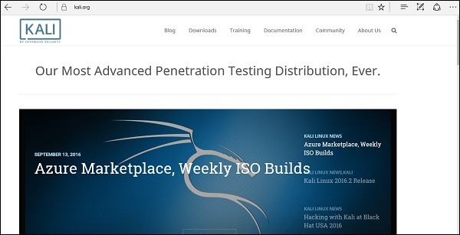
To install Kali Linux −
- First, we will download the Virtual box and install it.
- Later, we will download and install Kali Linux distribution.

Download and Install the Virtual Box
A Virtual Box is particularly useful when you want to test something on Kali Linux that you are unsure of. Running Kali Linux on a Virtual Box is safe when you want to experiment with unknown packages or when you want to test a code.
With the help of a Virtual Box, you can install Kali Linux on your system (not directly in your hard disk) alongside your primary OS which can MAC or Windows or another flavor of Linux.
Let’s understand how you can download and install the Virtual Box on your system.
Step 1 − To download, go to https://www.virtualbox.org/wiki/Downloads. Depending on your operating system, select the right package. In this case, it will be the first one for Windows as shown in the following screenshot.
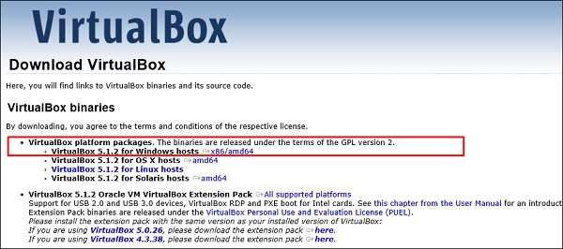
Step 2 − Click Next.
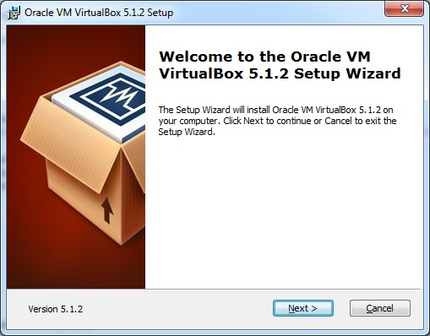
Step 3 − The next page will give you options to choose the location where you want to install the application. In this case, let us leave it as default and click Next.
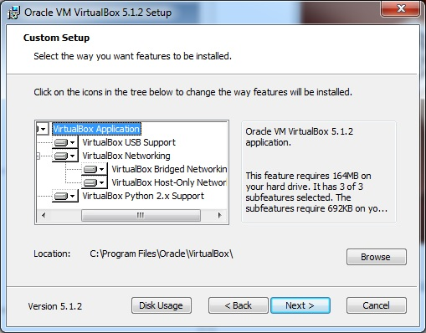
Step 4 − Click Next and the following Custom Setup screenshot pops up. Select the features you want to be installed and click Next.
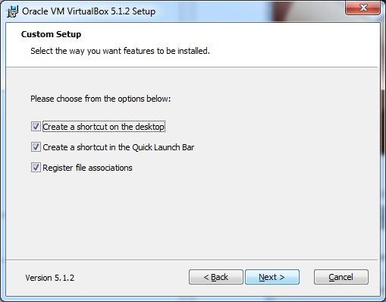

Step 5 − Click Yes to proceed with the installation.
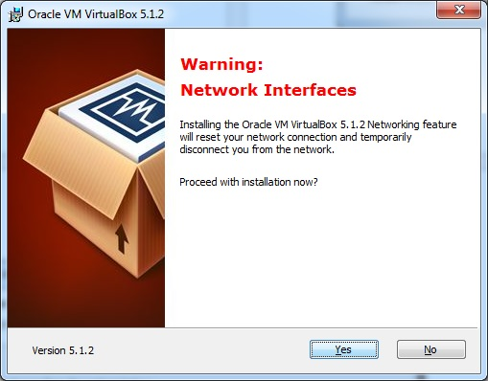
Step 6 − The Ready to Install screen pops up. Click Install.
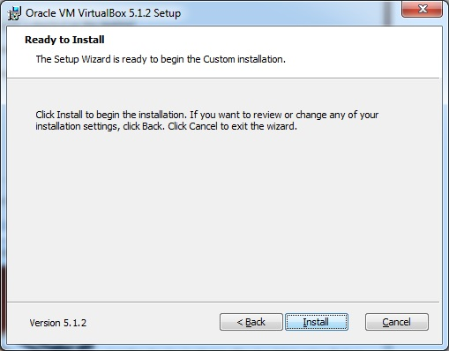

Step 7 − Click the Finish button.
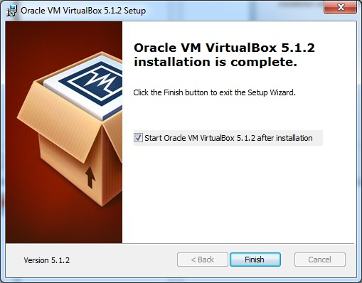
The Virtual Box application will now open as shown in the following screenshot. Now we are ready to install the rest of the hosts for this manual and this is also recommended for professional usage.
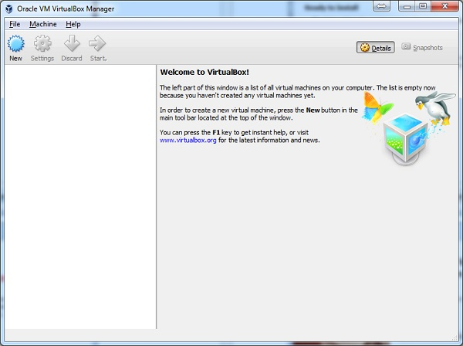

Install Kali Linux
Now that we have successfully installed the Virtual Box, let’s move on to the next step and install Kali Linux.

Step 1 − Download the Kali Linux package from its official website: https://www.kali.org/downloads/
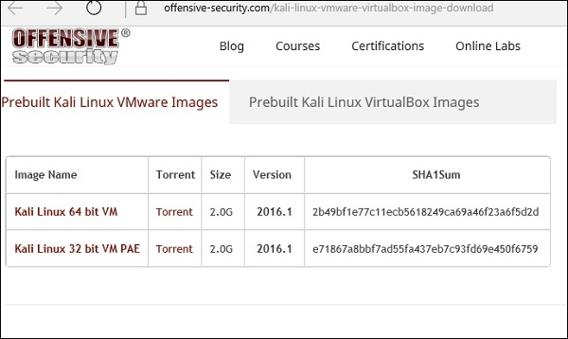
Step 2 − Click VirtualBox → New as shown in the following screenshot.
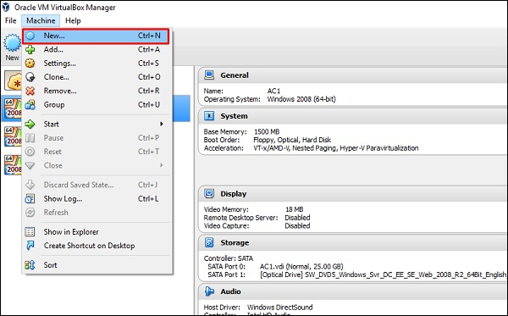

Step 3 − Choose the right virtual hard disk file and click Open.
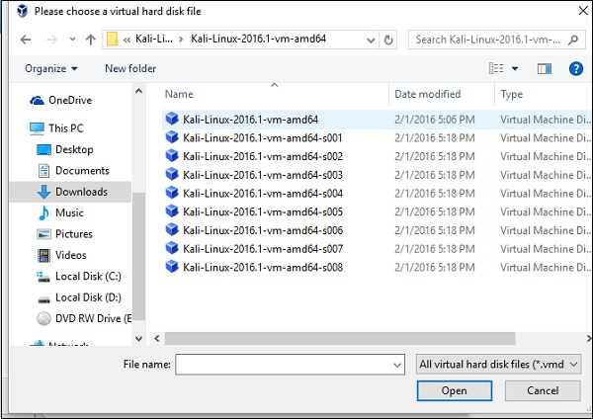
Step 4 − The following screenshot pops up. Click the Create button.
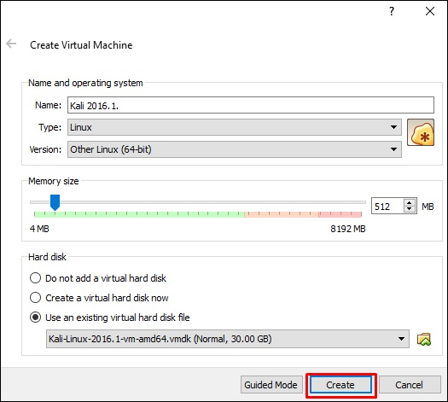

Step 5 − Start Kali OS. The default username is root and the password is toor.
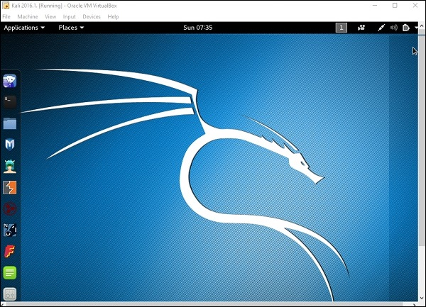

Update Kali
It is important to keep updating Kali Linux and its tools to the new versions, to remain functional. Following are the steps to update Kali.
Step 1 − Go to Application → Terminal. Then, type “apt-get update” and the update will take place as shown in the following screenshot.
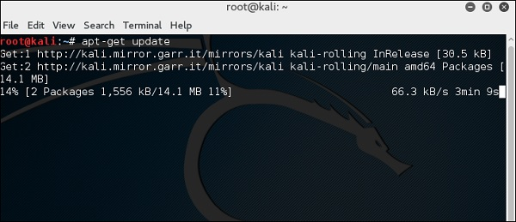
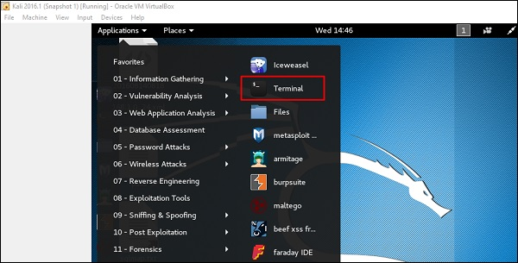
Step 2 − Now to upgrade the tools, type “apt-get upgrade” and the new packages will be downloaded.
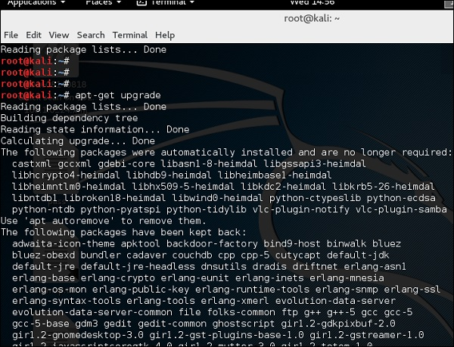
Step 3 − It will ask if you want to continue. Type “Y” and “Enter”.
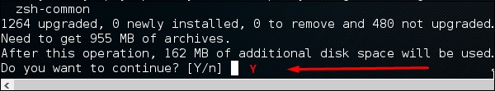
Step 4 − To upgrade to a newer version of Operating System, type “apt-get distupgrade”.
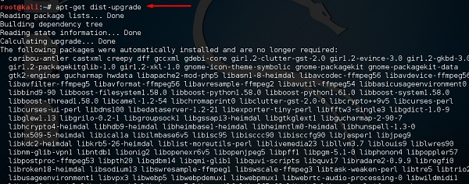

Laboratory Setup
In this section, we will set up another testing machine to perform the tests with the help of tools of Kali Linux.
Step 1 − Download Metasploitable, which is a Linux machine. It can be downloaded from the official webpage of Rapid7: https://information.rapid7.com/metasploitabledownload.html?LS=1631875&CS=web
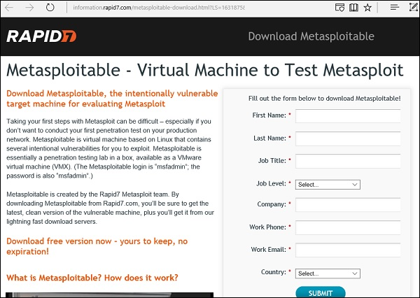
Step 2 − Register by supplying your details. After filling the above form, we can download the software.
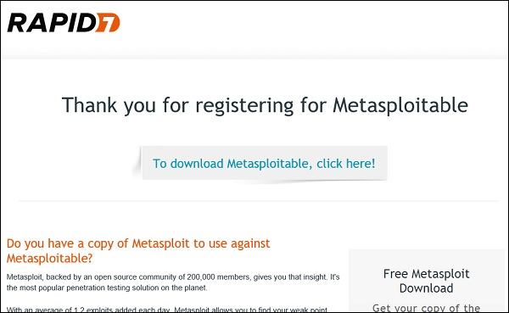
Step 3 − Click VirtualBox → New.
Step 4 − Click “Use an existing virtual hard disk file”. Browse the file where you have downloaded Metasploitable and click Open.
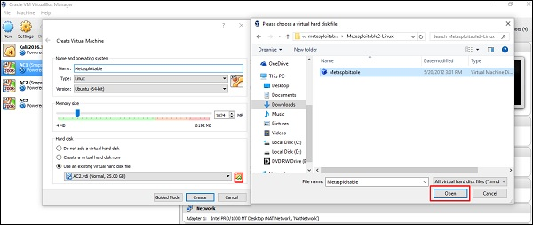

Step 5 − A screen to create a virtual machine pops up. Click “Create”.
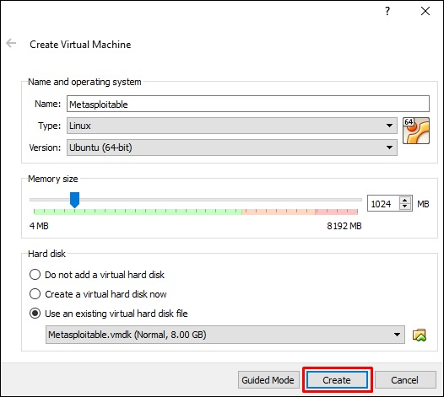
The default username is msfadmin and the password is msfadmin.
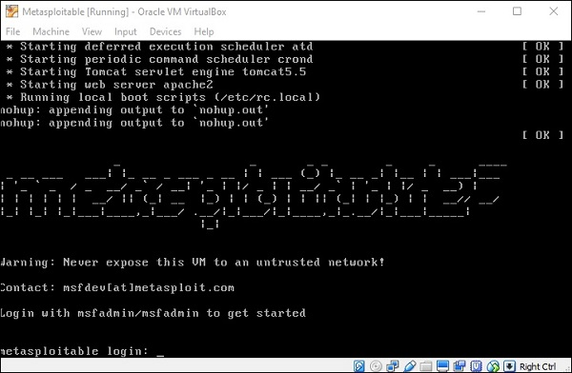

Experiment 1: Implementation of cryptanalysis on caesar cipher. Here is a sample Encrypted Message:
GFS WMY OG LGDVS MF SFNKYHOSU ESLLMRS, PC WS BFGW POL DMFRQMRS, PL OG CPFU M UPCCSKSFO HDMPFOSXO GC OIS LMES DMFRQMRS DGFR SFGQRI OG CPDD GFS LISSO GK LG, MFU OISF WS NGQFO OIS GNNQKKSFNSL GC SMNI DSOOSK. WS NMDD OIS EGLO CKSJQSFODY GNNQKKPFR DSOOSK OIS 'CPKLO', OIS FSXO EGLO GNNQKKPFR DSOOSK OIS 'LSNGFU' OIS CGDDGWPFR EGLO GNNQKKPFR DSOOSK OIS 'OIPKU', MFU LG GF, QFOPD WS MNNGQFO CGK MDD OIS UPCCSKSFO DSOOSKL PF OIS HDMPFOSXO LMEHDS. OISF WS DGGB MO OIS NPHISK OSXO WS WMFO OG LGDVS MFU WS MDLG NDMLLPCY POL LYEAGDL. WS CPFU OIS EGLO GNNQKKPFR LYEAGD MFU NIMFRS PO OG OIS CGKE GC OIS 'CPKLO' DSOOSK GC OIS HDMPFOSXO LMEHDS, OIS FSXO EGLO NGEEGF LYEAGD PL NIMFRSU OG OIS CGKE GC OIS 'LSNGFU' DSOOSK, MFU OIS CGDDGWPFR EGLO NGEEGF LYEAGD PL NIMFRSU OG OIS CGKE GC OIS 'OIPKU' DSOOSK, MFU LG GF, QFOPD WS MNNGQFO CGK MDD LYEAGDL GC OIS NKYHOGRKME WS WMFO OG LGDVS.

Step:1

Step2:
OPen the encrypted message only in Notepad.

Find the frequency of each letter in the encrypted message. to find the frequency of all

the letters appearing in the intercept. For this intercept we get the values given in the table below.

Step3:
Follow the table below to find the characters to be substituted for the given encrypted
message.

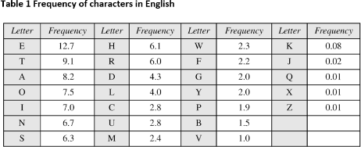

Step4:
Click ctrl+H in the notepad
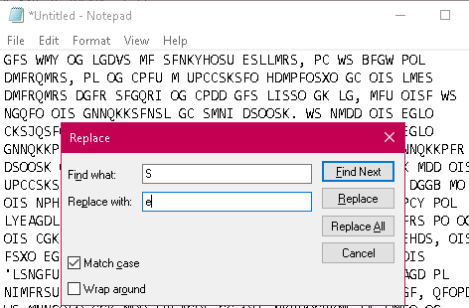
Click the check box: Match case

Step 5:
Start substituting one by one letters by following the sequence
S → e | O → t |  | I → h |  | G → o |  | F → n |  | M → a | X → x
W → wB → k |  | U → d |  | D → l |  | K → r |  | P → i |  | L → s V → v
H → p |  | A → b |  | X → x |  | Y → y |  | E → m |  | N →c C→f
R →g |  | Q → u |  | J → q

Step 6:
Final decrypted text will be as shown below.

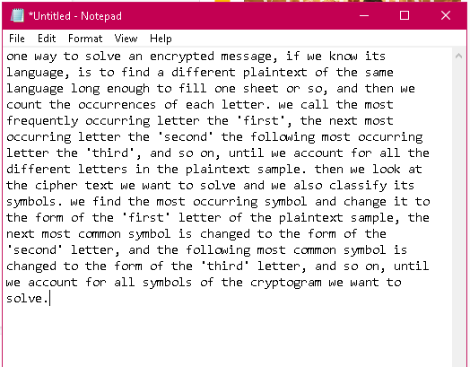

Experiment 2: Implementation of Cryptanalysis using RSA.
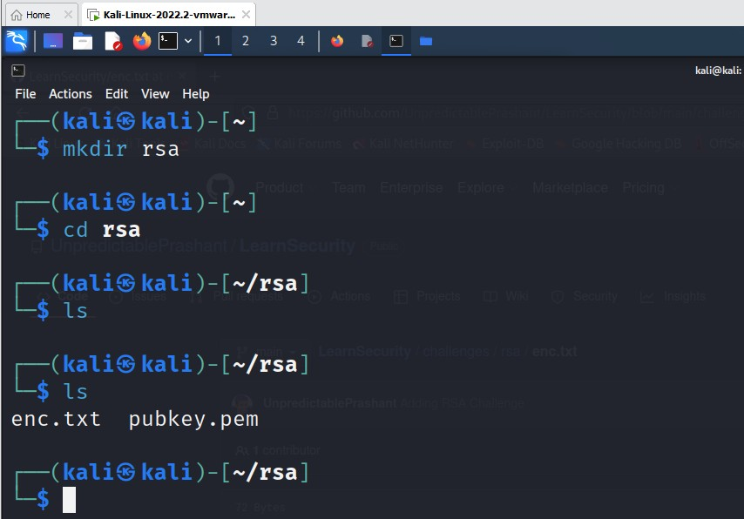

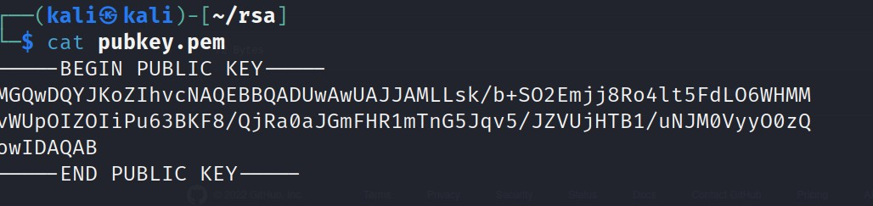
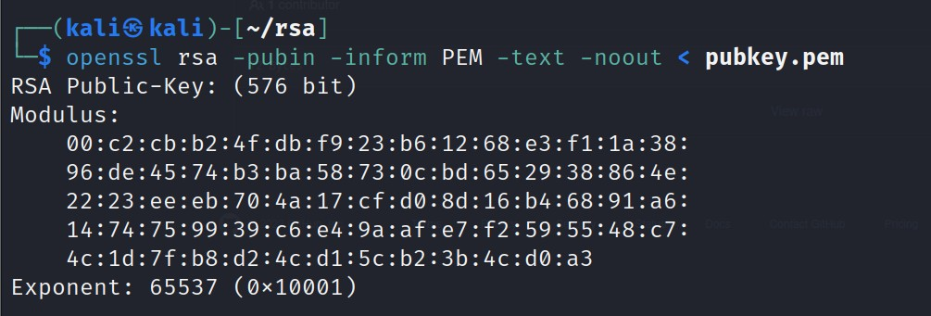

Copy the hexadecimal decimal code into a notepad as n value. As it is a hexadecimal we can convert it into decimal for gaining the plaintext.

Hexadecimal to decimal convertor

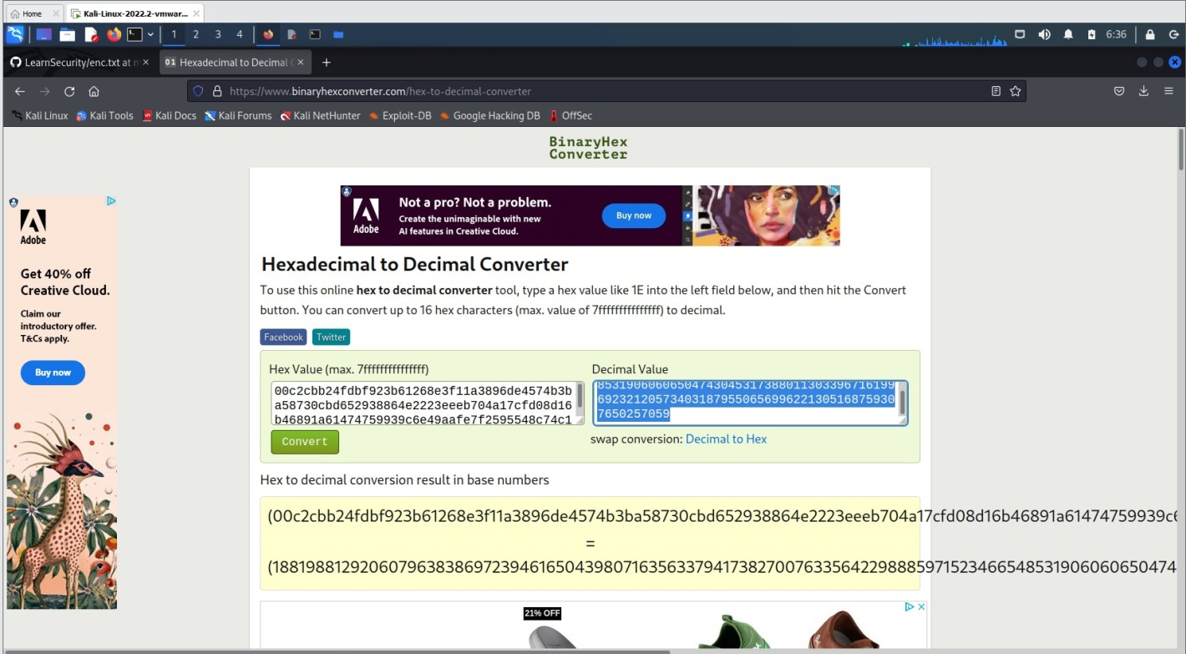

Paste the decimal code in the notepad as n value

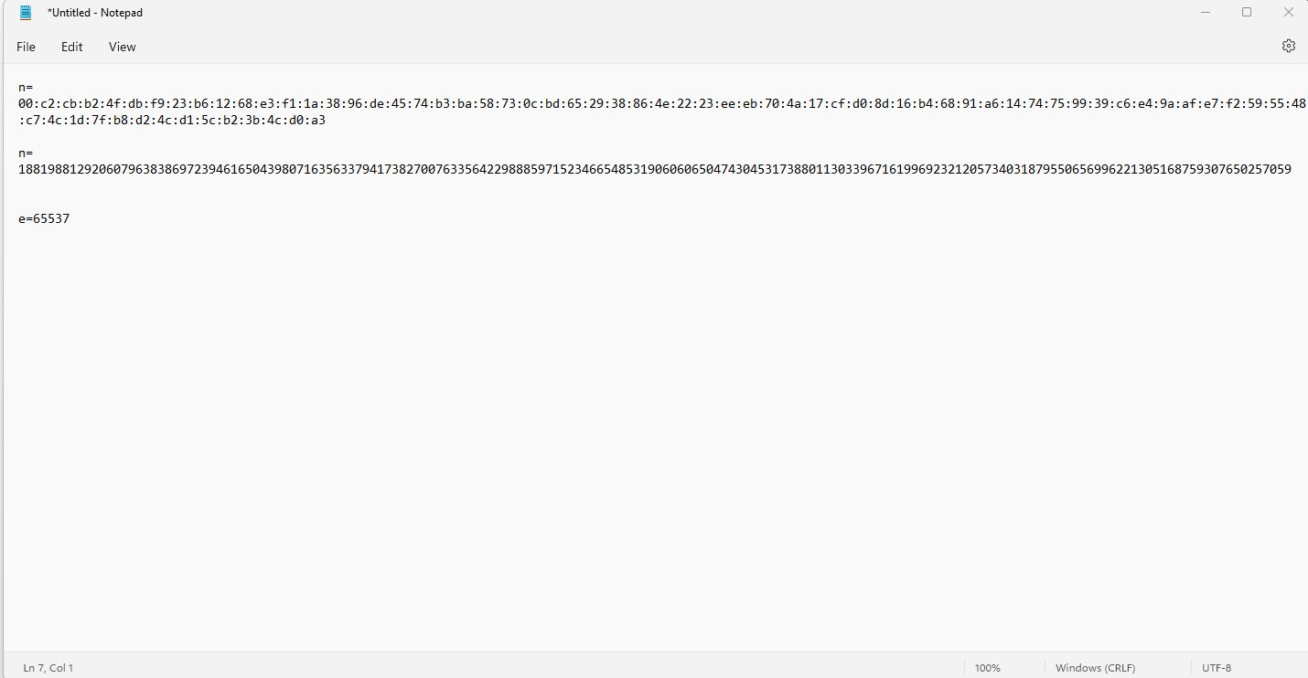

Need to factorize n
So goto website factordb.com click search, paste decimal value of n

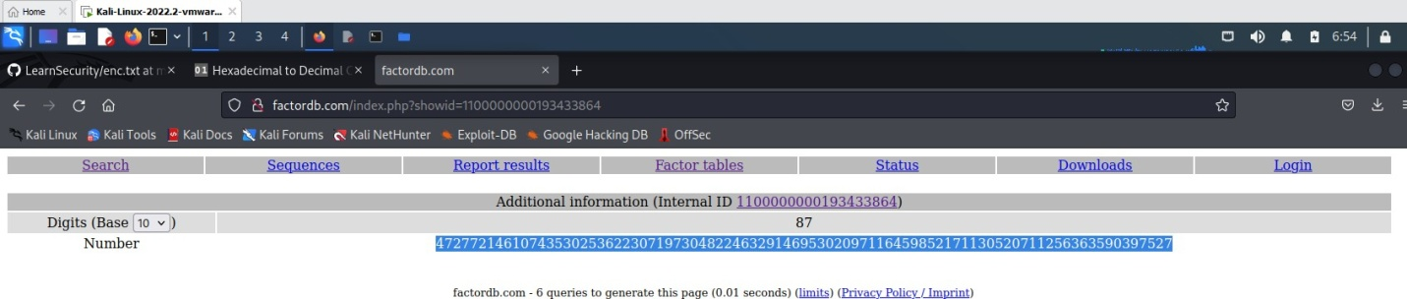

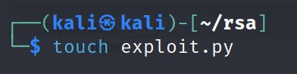
Create a exploit.py
To install pycrypto

pip install pycrypto
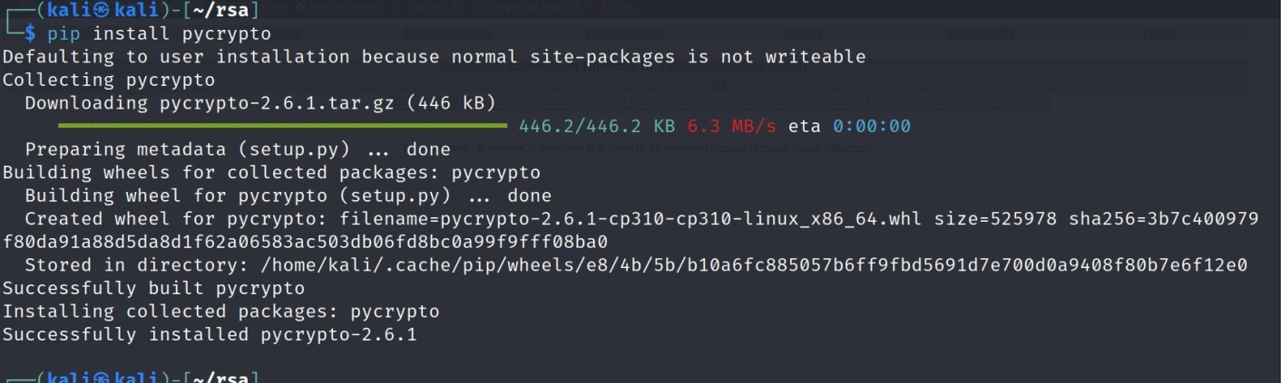
Copy the code in the exploit.py file and paste it from Crypto.PublicKey import RSA
from Crypto.Util.number import inverse import base64
n = 1881988129206079638386972394616504398071635633794173827007633564229888597152
3466548531906060650474304531738801130339671619969232120573403187955065699622
1305168759307650257059
e = 65537
p = 3980750864240649373971255005503864911990643623425267084063851895759463889572
61768583317
q = 4727721461074353025362230719730482246329146953020971164598521711305207112563
63590397527
phi_n = (p - 1)*(q - 1) d = inverse(e, phi_n)
key = RSA.construct((n, e, d, p, q)) fn = "private.pem"
with open(fn, "wb") as f: f.write(key.exportKey())

Execute exploit.py file

python exploit.py

To decrypt the text
openssl rsautl -decrypt -in encryptedFile -out decryptedFileName -inkey privateKey.pem

Experiment 3: Examination of a website to test the vulnerability of attacks. – DVWA setup & SQLi
Step 1: Download VMWare or virtual box and Install kali linux Step2: Login to the kali linux by using the

Username: kali password: kali
Step 3: go to browser and search for DVWA in Kali Linux DVWA → is a vulnerable website
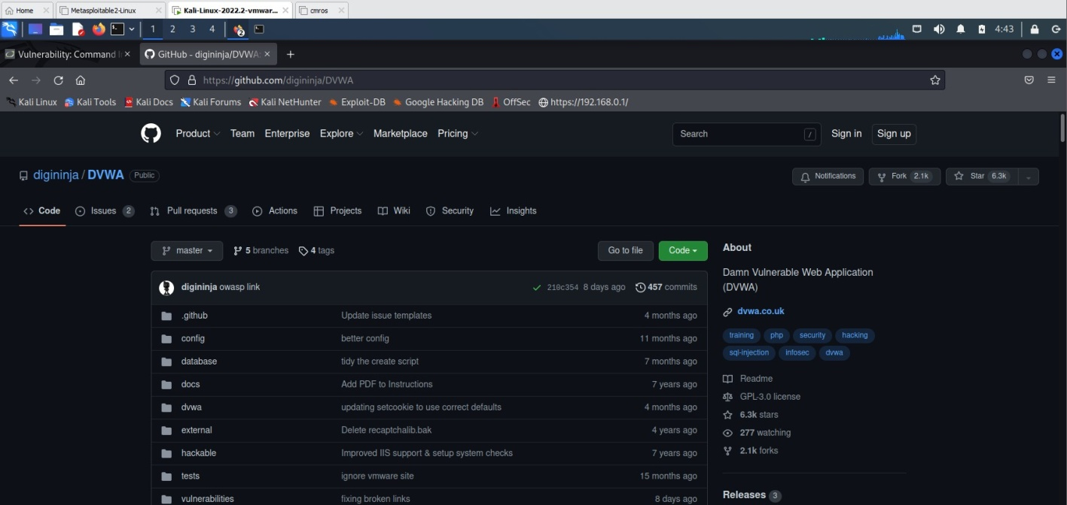

Installing DVWA:
git clone https://github.com/digininja/DVWA.git
// if any error occurs use sudo in front of git clone mv DVWA dvwa
chmod -R 777 dvwa/
// to get recursive permission we use -R cd dvwa/config
//there will be a dummy file so we can copy to get a new file
//cp used to copy the content of the file cp config.inc.php.dist config.inc.php
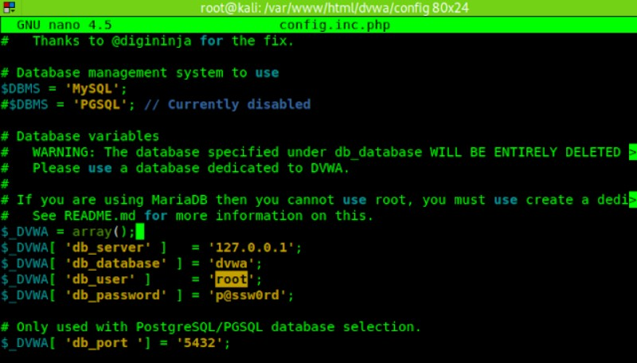
cat or nano config.inc.php

sudo service mysql start sudo mysql -u root -p

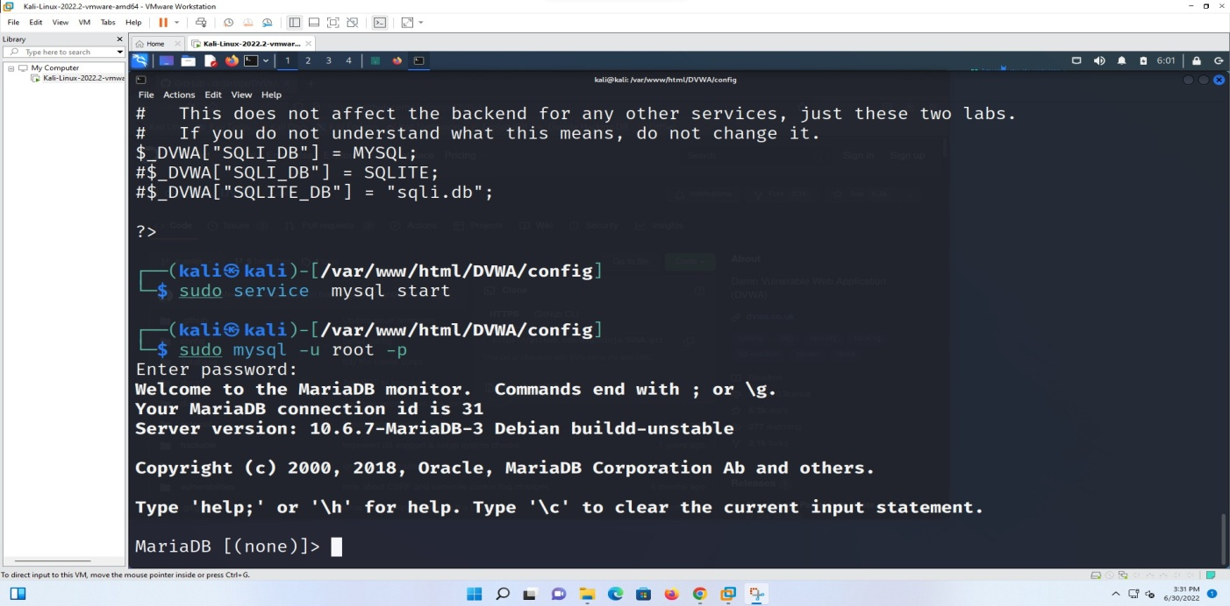

create database dvwa
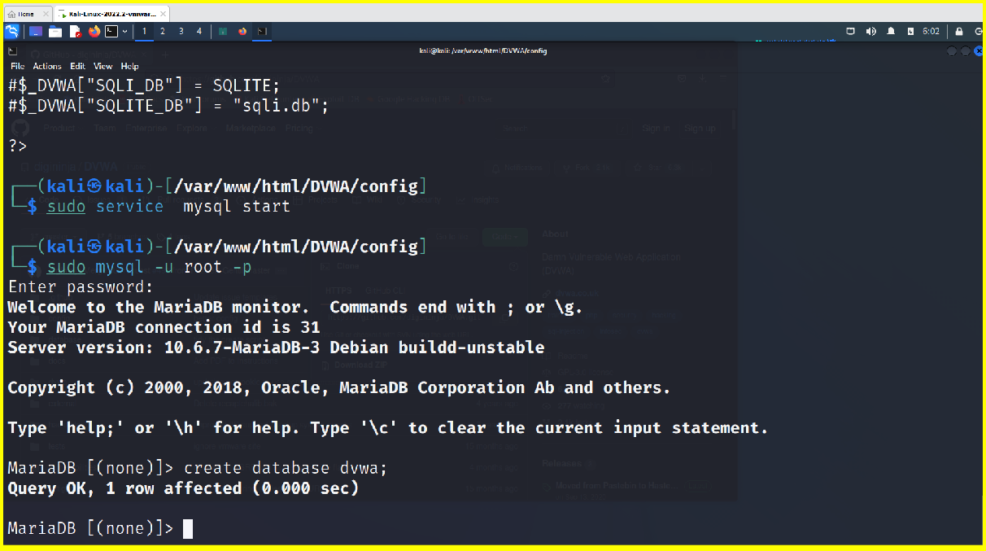

create user dvwa@localhostidentifies by'p@ssw0rd':
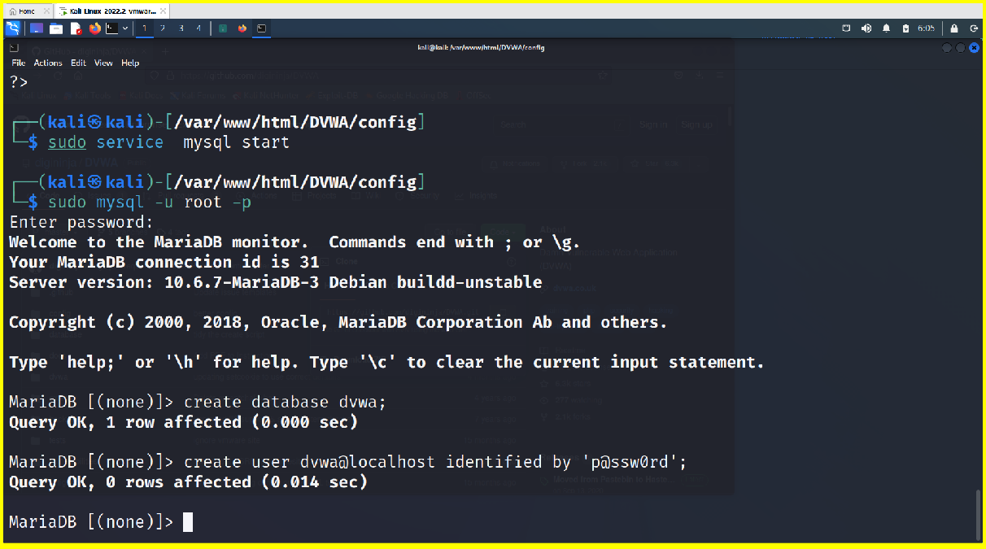

grant all on dvwa.* to dvwa@localhosr;
flush privileges;
exit;
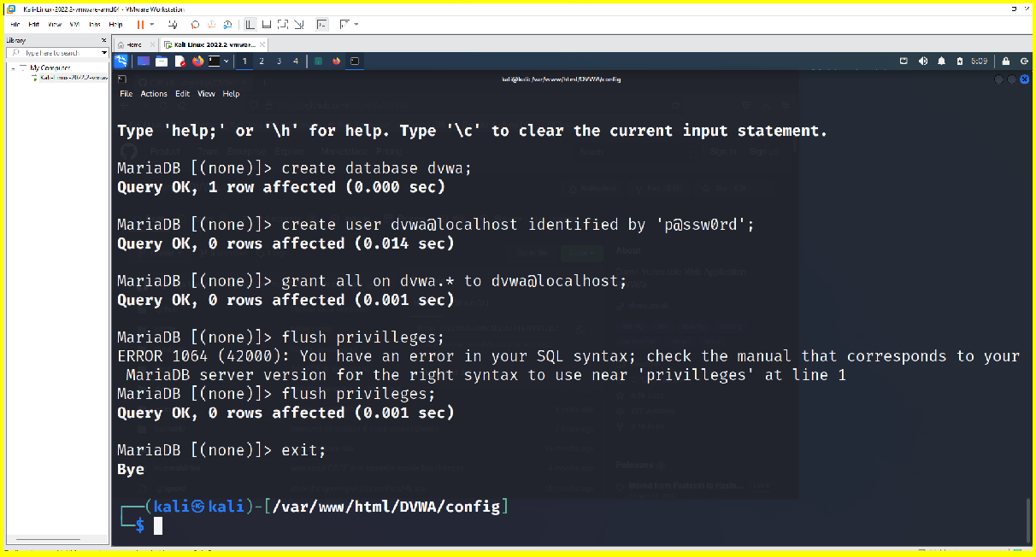

sudo service apache2 start

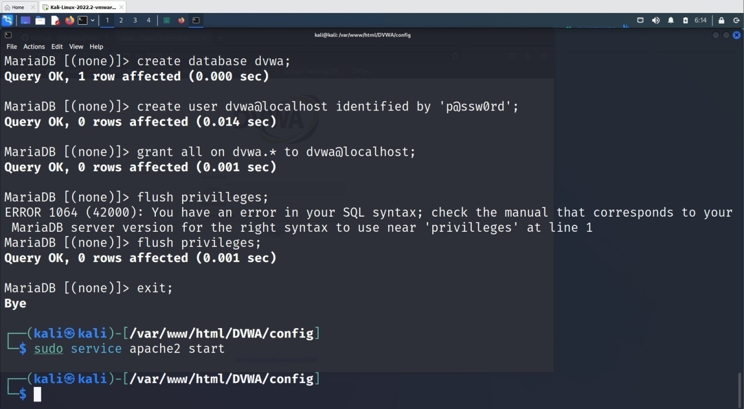

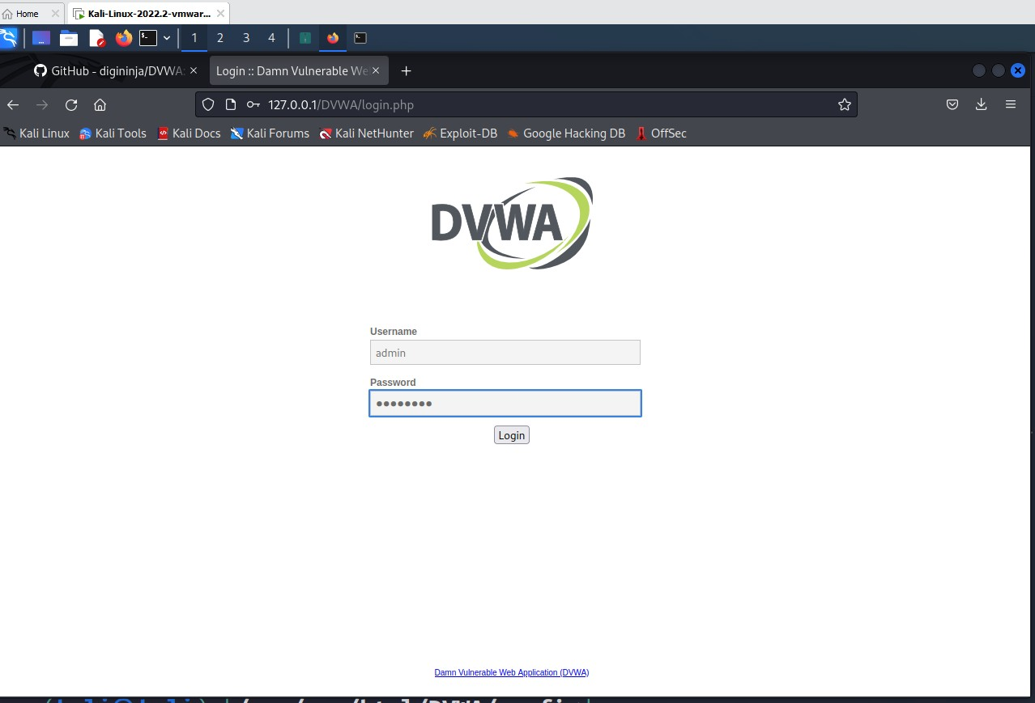
goto browser and give http://localhost/DVWA or http://127.0.0.1/DVWA/login.php

username: admin password: password
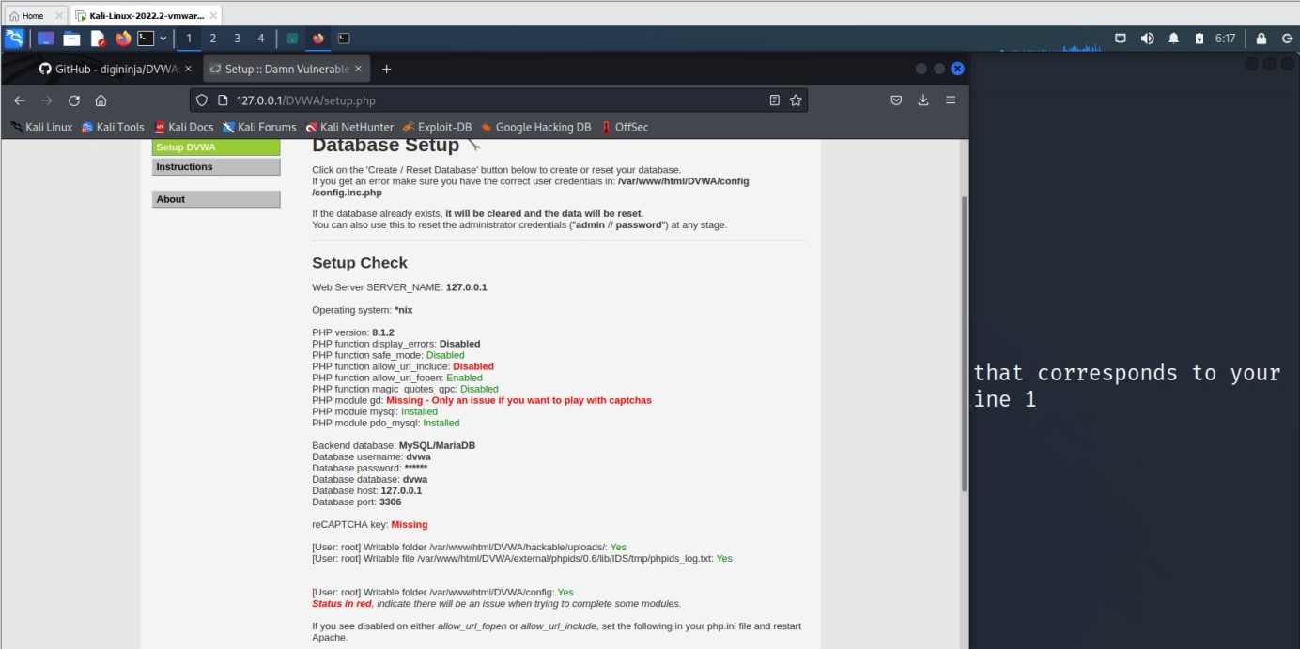

click create database
we get http://127.0.0.1/DVWA/index.php
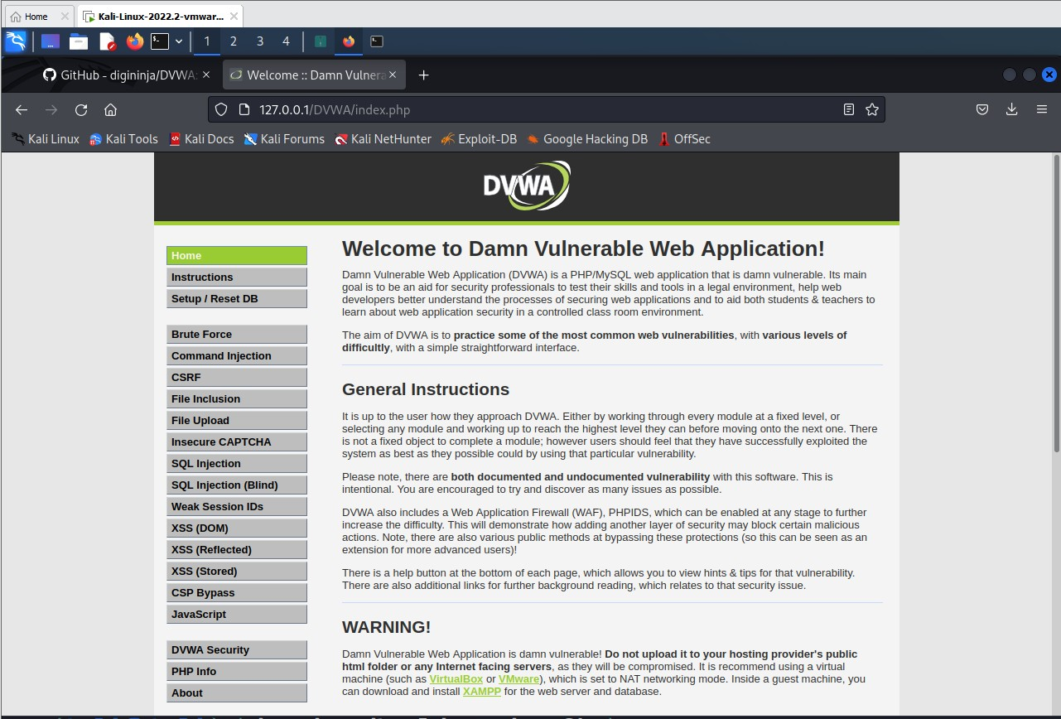

Goto DVWA security

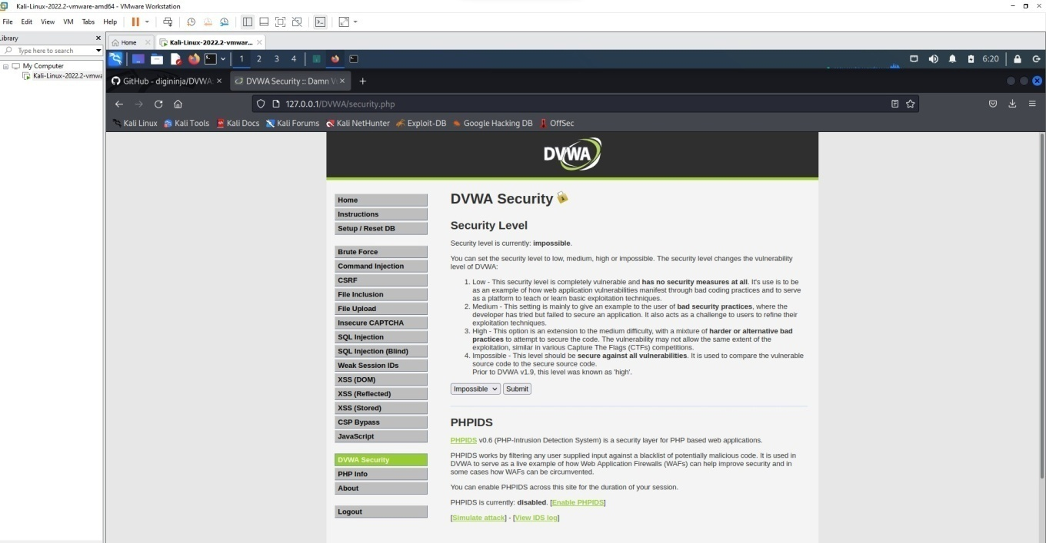

Click on impossible
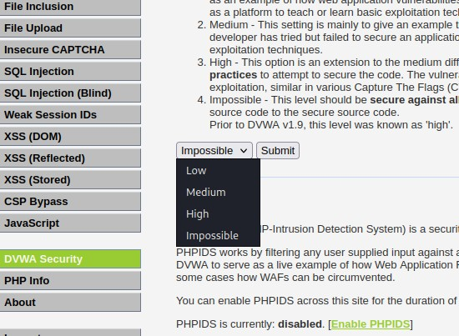

set as LOW.

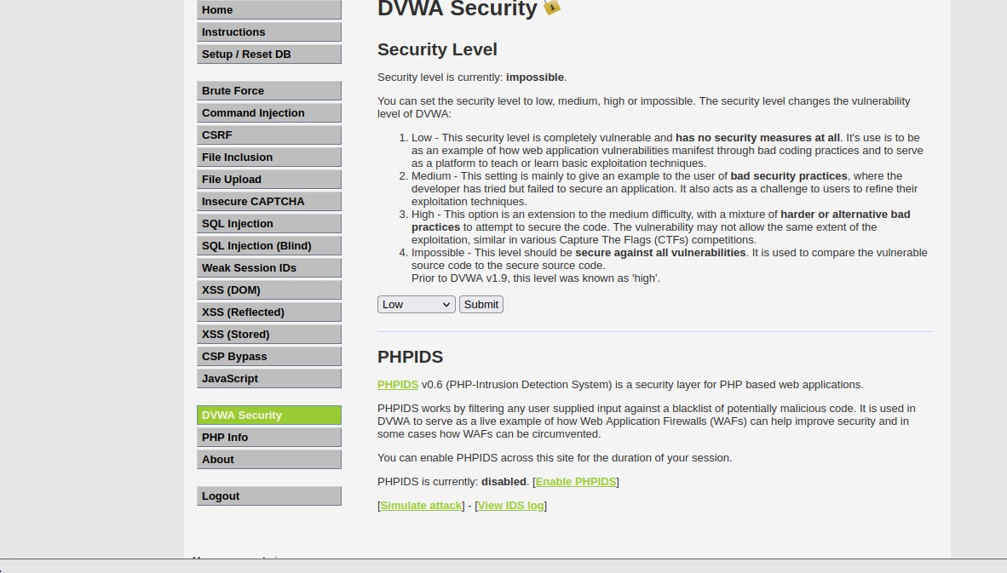

Click submit. Attacking the system:
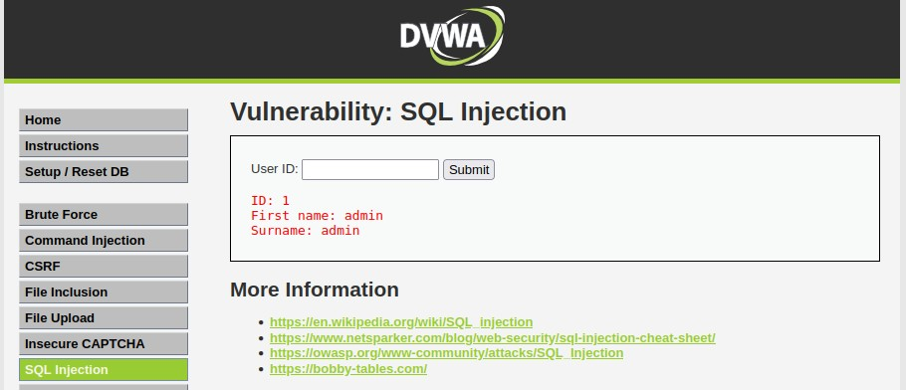
- SQLInjection: Enter 1 and Click submit
Enter 2 and Click submit

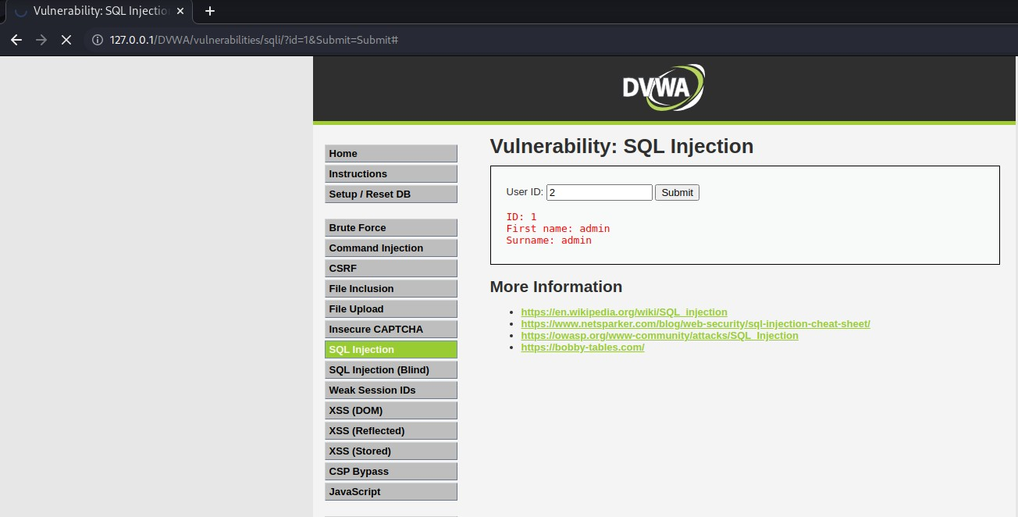

Enter %’ or ‘1’=’1
It displays all the information.
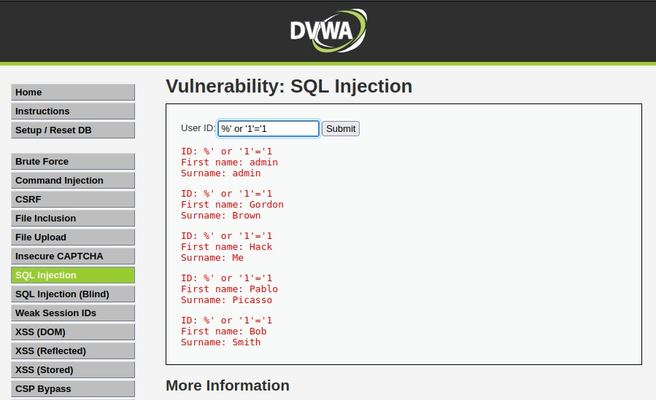

Open burp suite

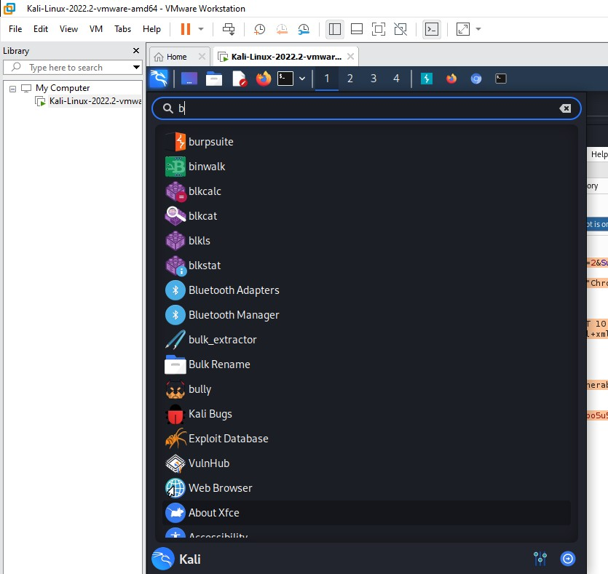

open burp suite
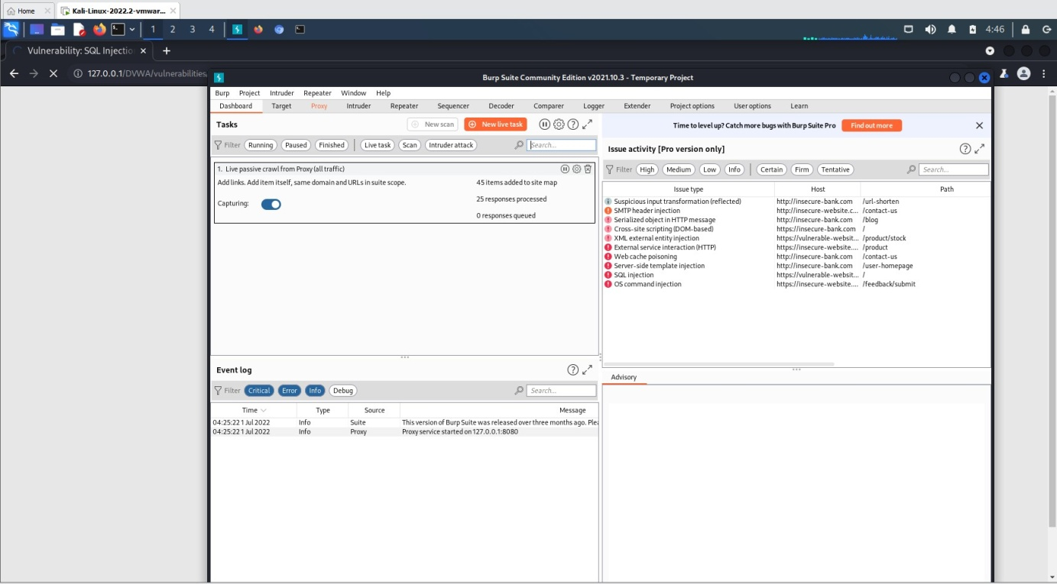

click proxy

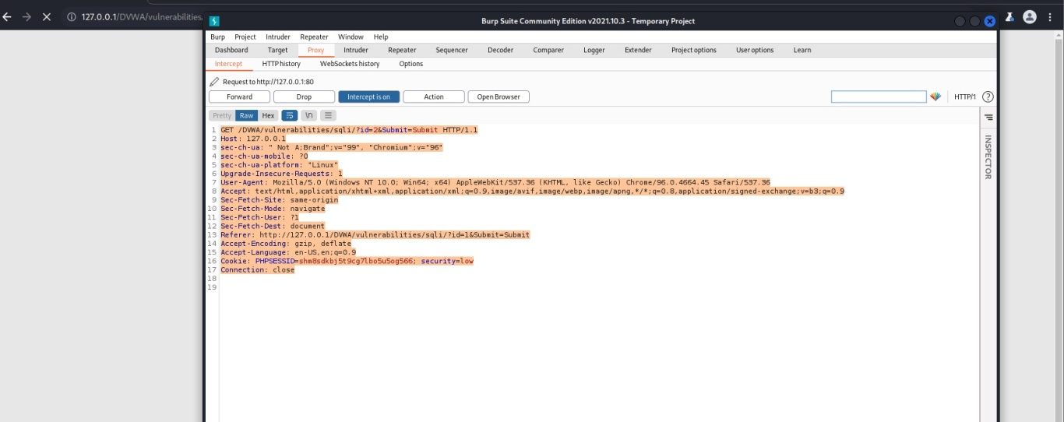

it should be that interception on the data will be opened
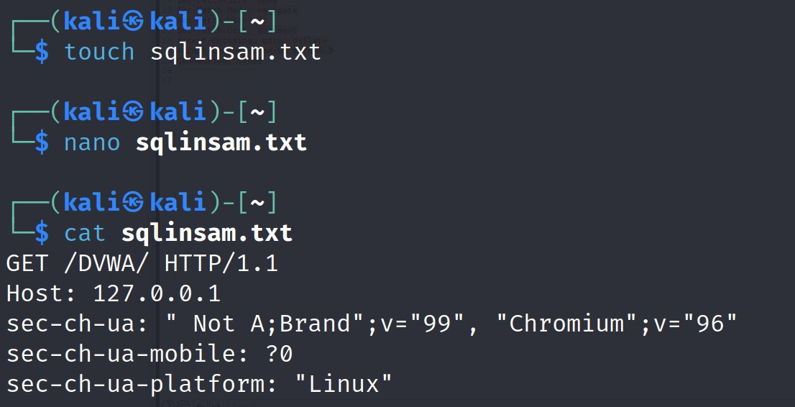
In the linux terminal create a file with any file extension. copy the content and paste in the file created using terminal
to view the content of the created file.

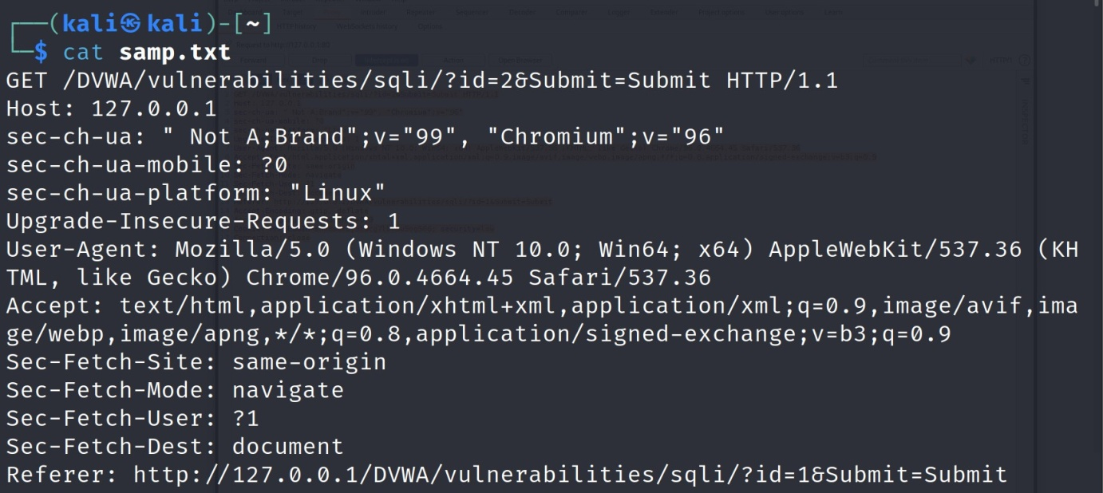

- Let’s use sqlmap to exploit it:
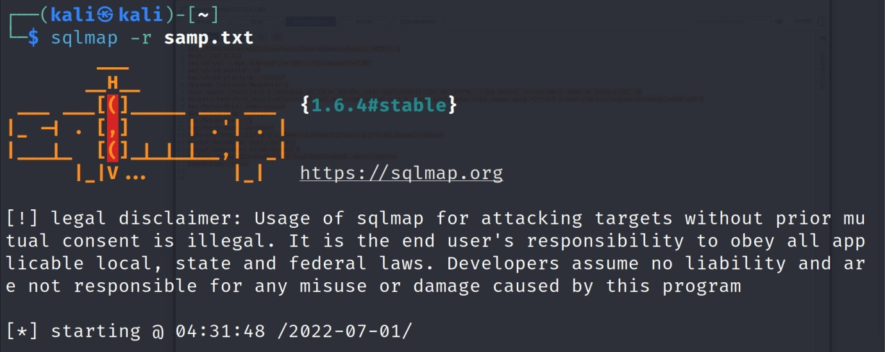
- sqlmap –r sqlmaplow.txt

To know the databases using sqlmap exploit
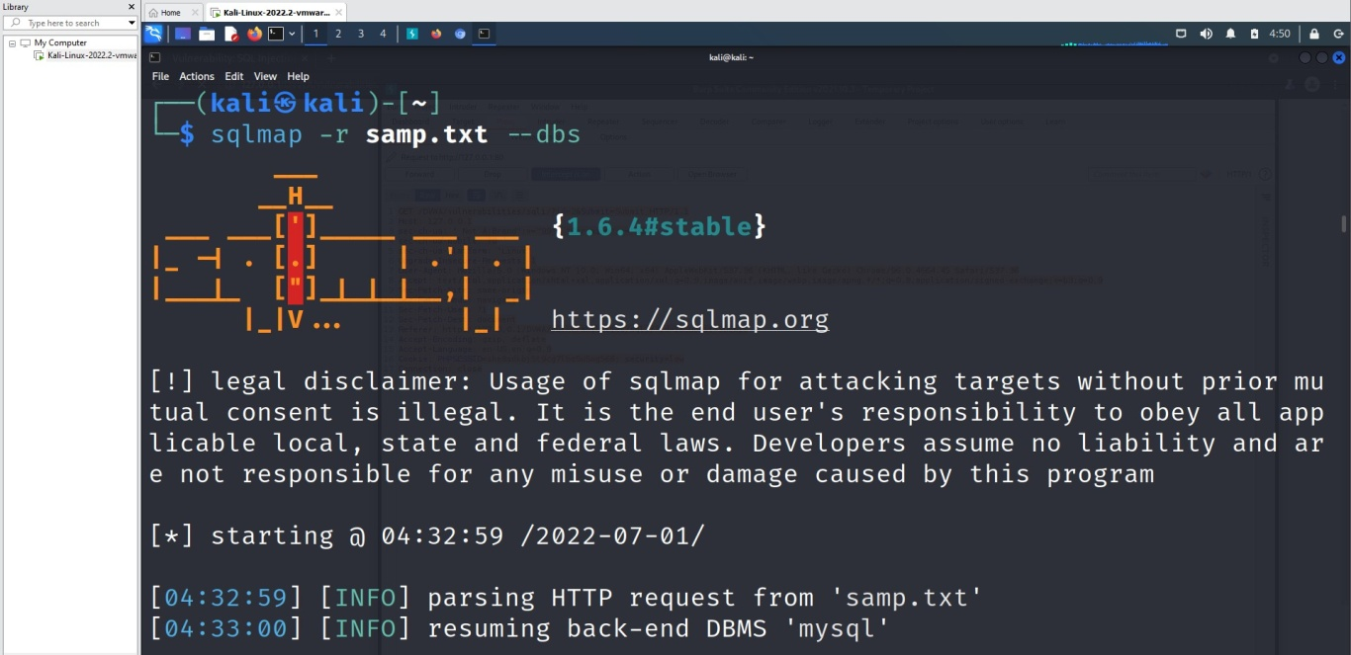

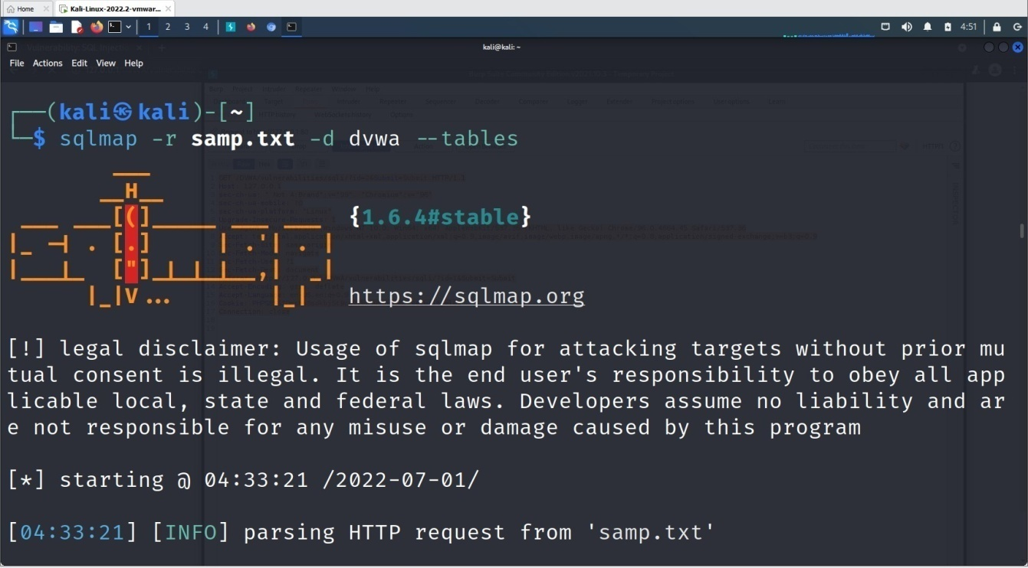

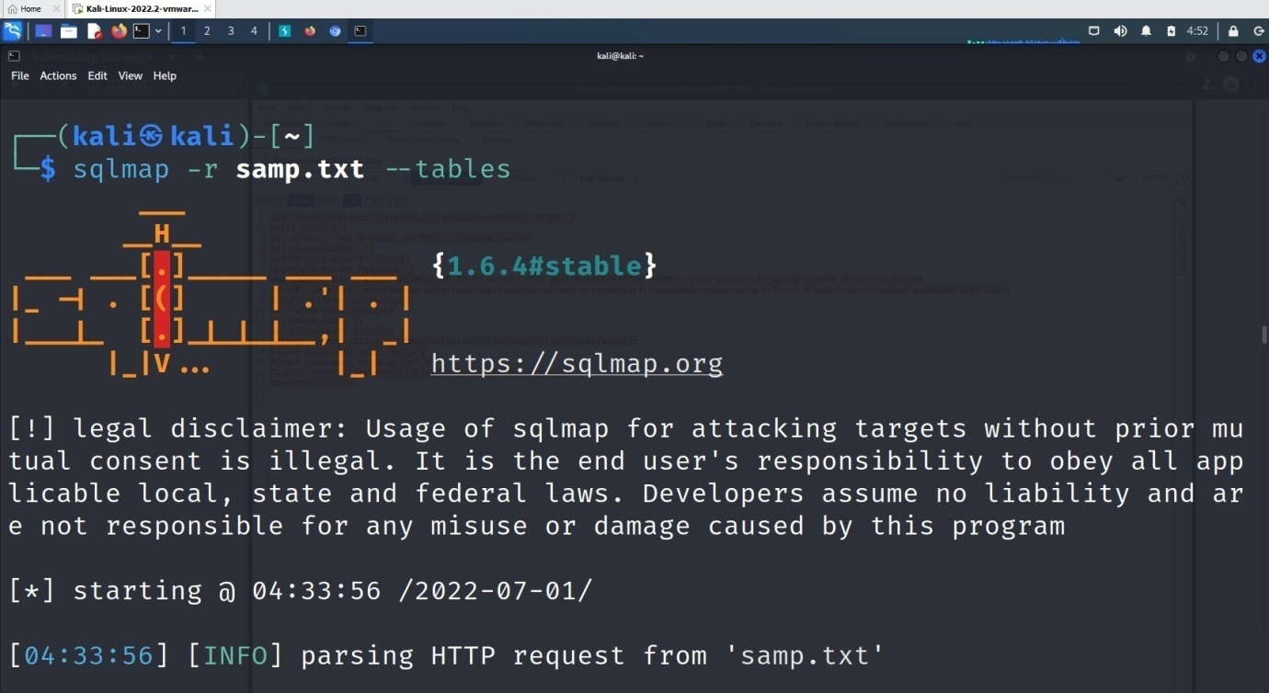

open table columns
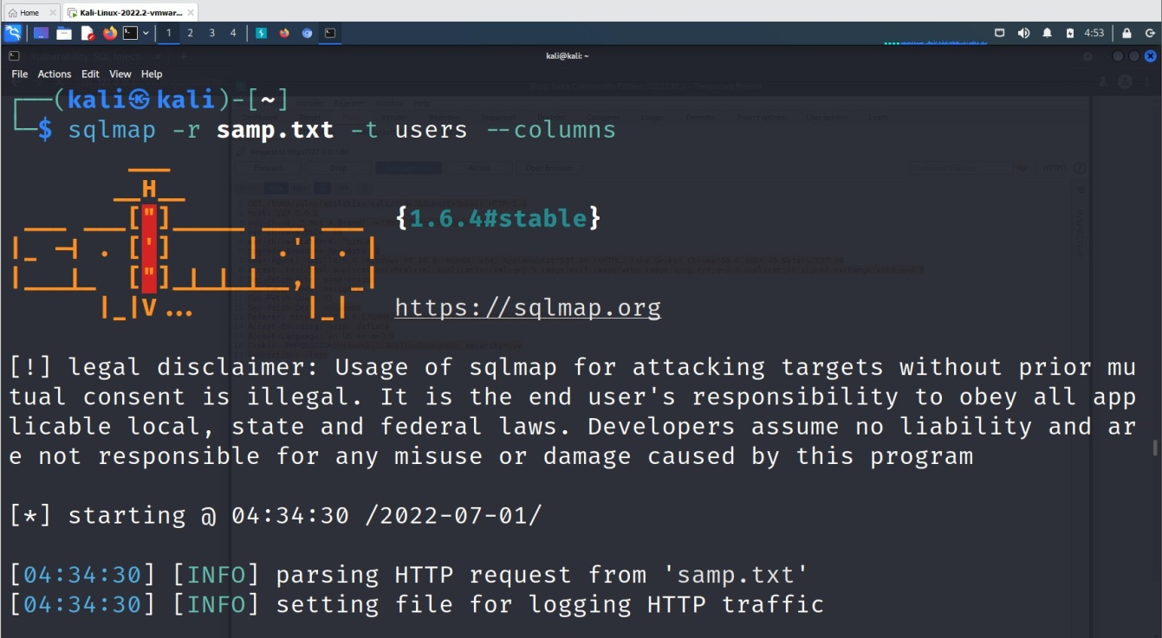

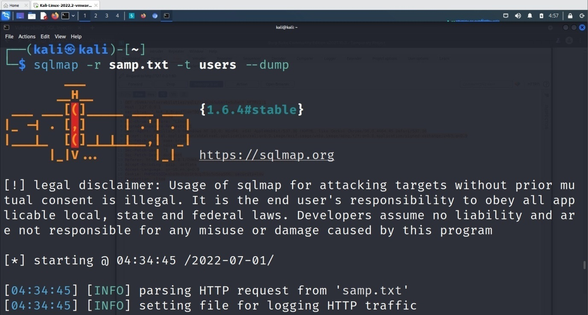

we get multiple login ids and passwords in hash values

Experiment 4: Examination of a website to test the vulnerability of attacks. – XSS & CSRF & Command line injection attack.
— Command Injection Attack—

sudo service apache2 start
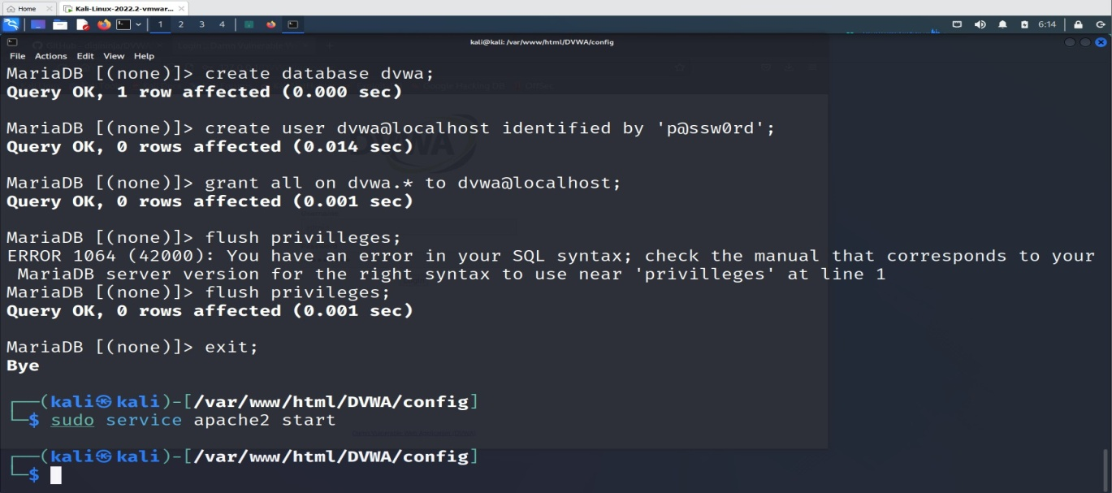

goto browser and give http://localhost/DVWA or http://127.0.0.1/DVWA/login.php

username: admin password: password

click create database
we get http://127.0.0.1/DVWA/index.php

Goto DVWA security

Click on impossible

Set as LOW and click Submit.

Enter IP address.
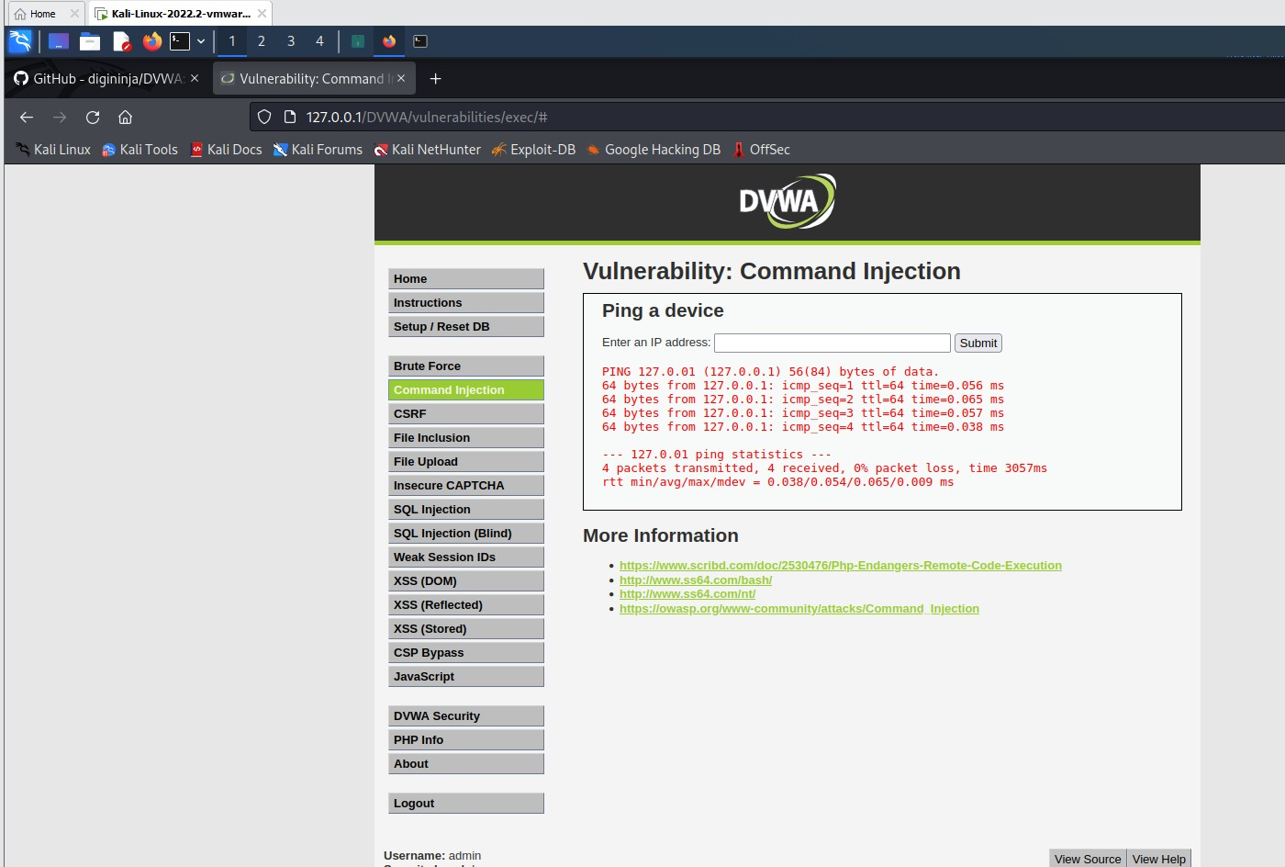

multiple commands using pipe or ; 127.0.0.1;ls

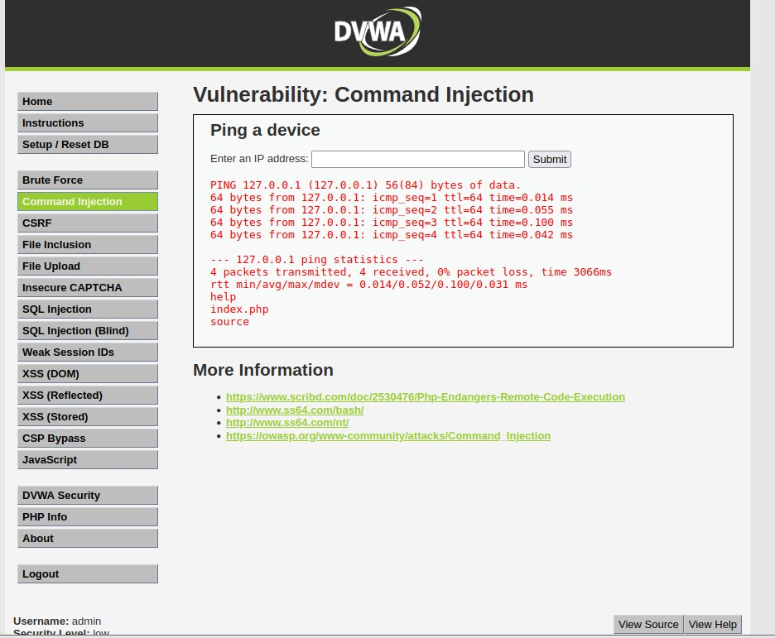

127.0.0.1;ls ../
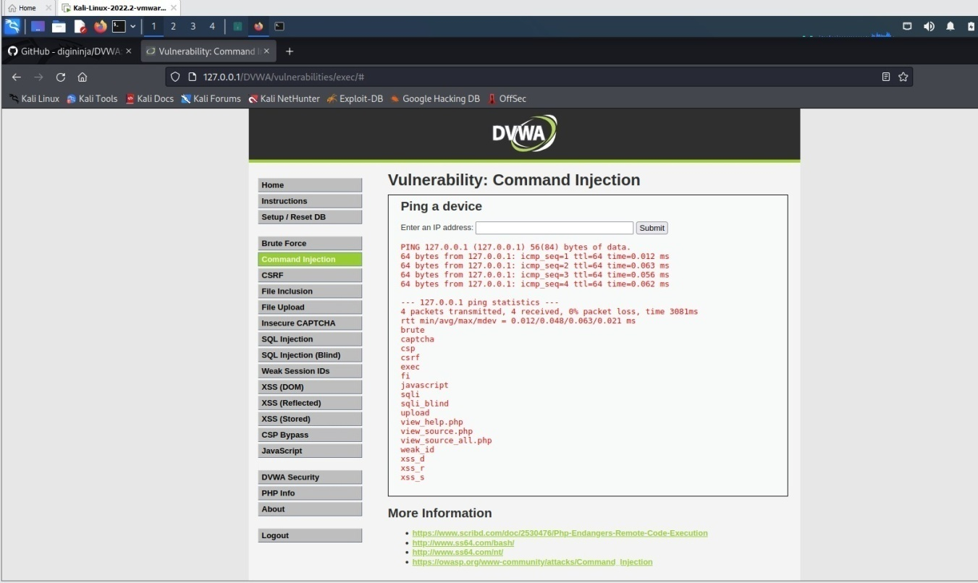
;cat ../view_source.php
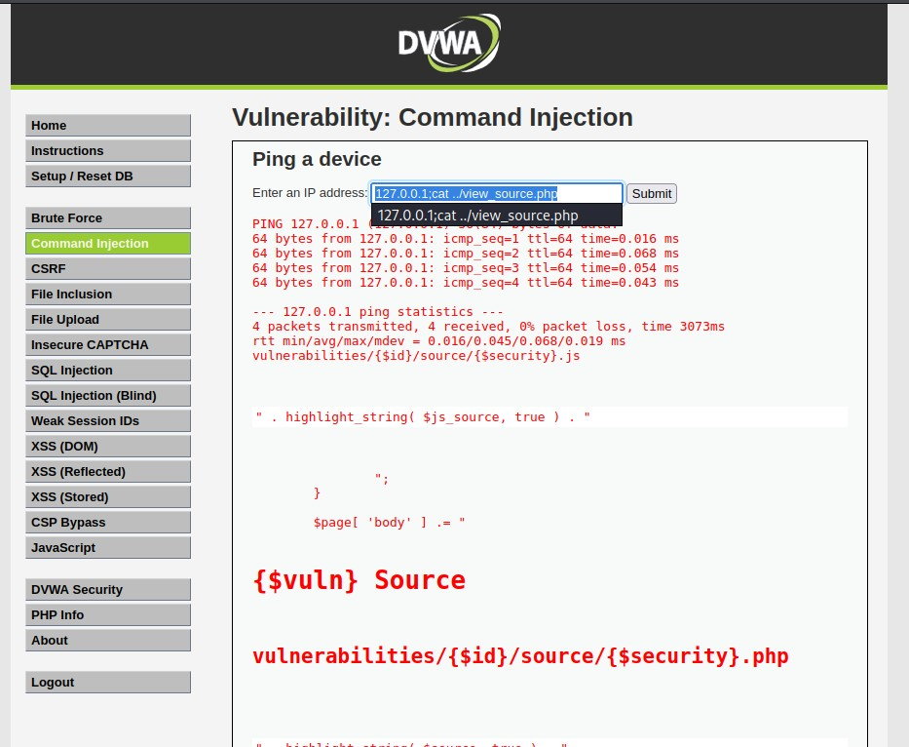

Use &&net user
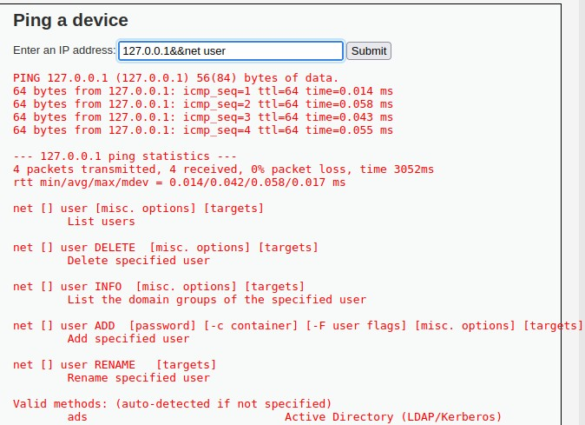

Use &net user
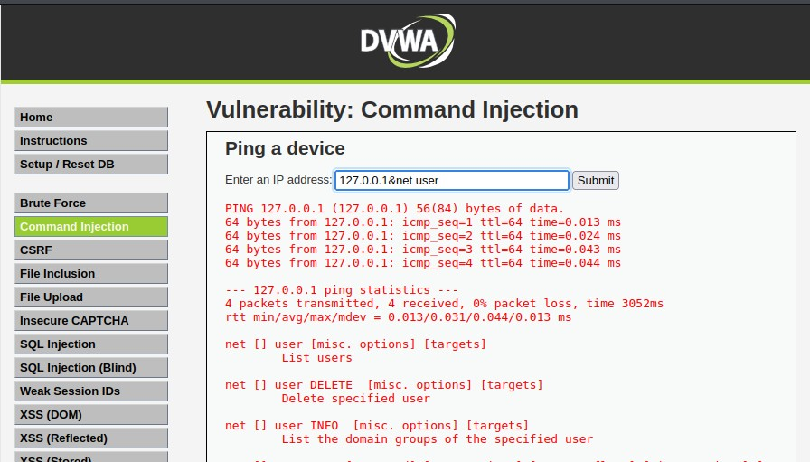

Open command prompt in the windows system and use the command ping 0.0.0.0&net user
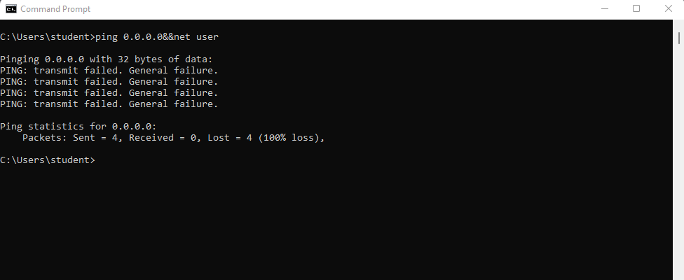

Now use the command ping 0.0.0.0&Rnet user – replace & with &&

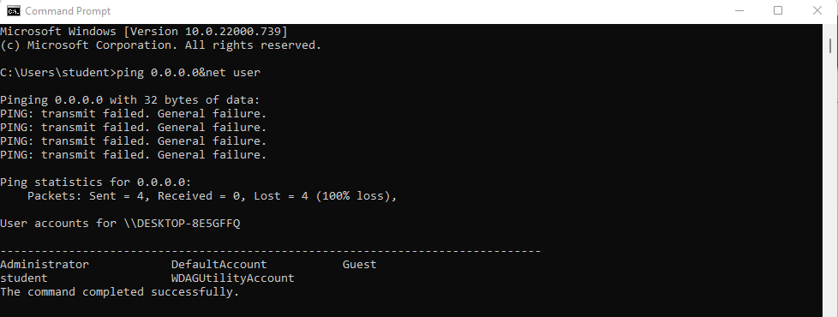

—------------------------------------------------XSS Attack------------------------------------------------------------

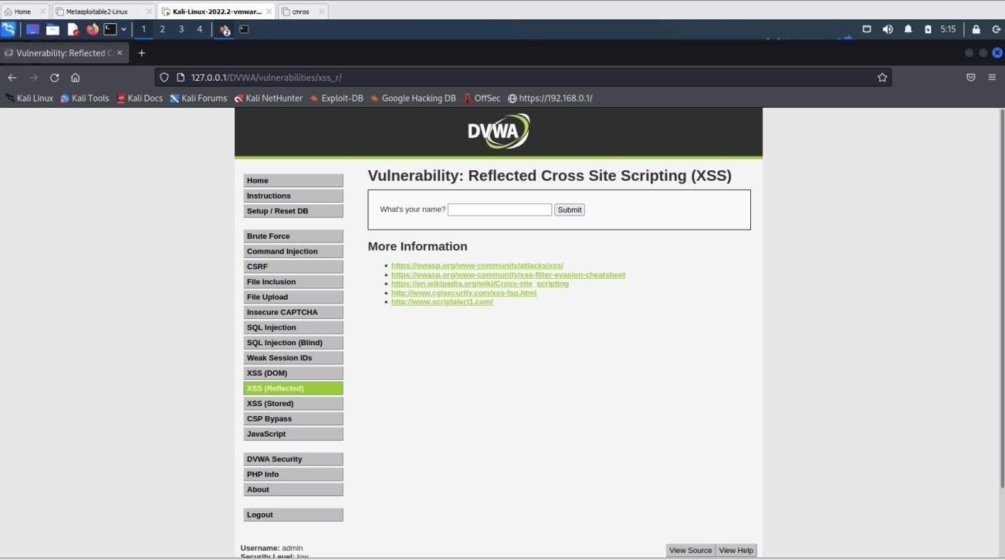
Click XSS Reflection
Enter any name in the text box and click submit.
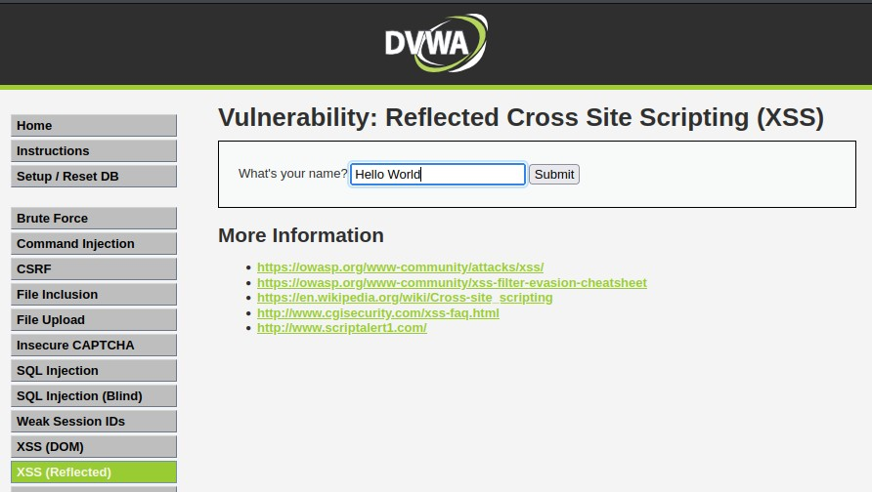
It displays as

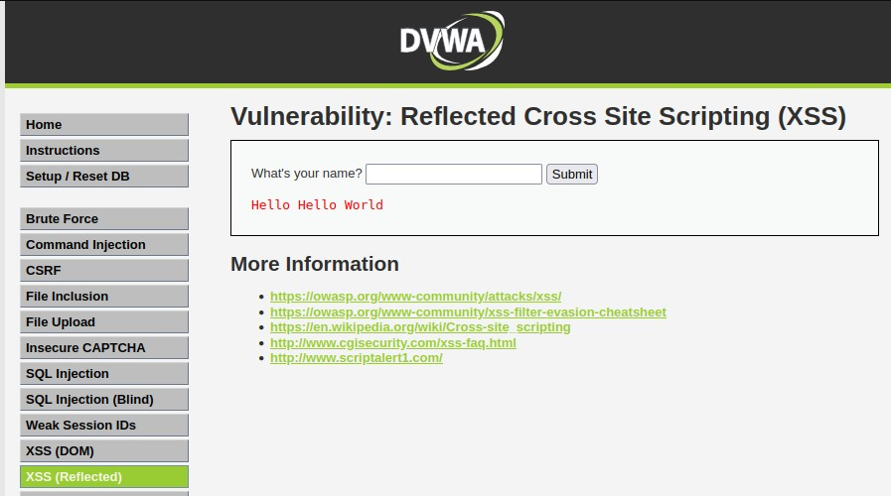
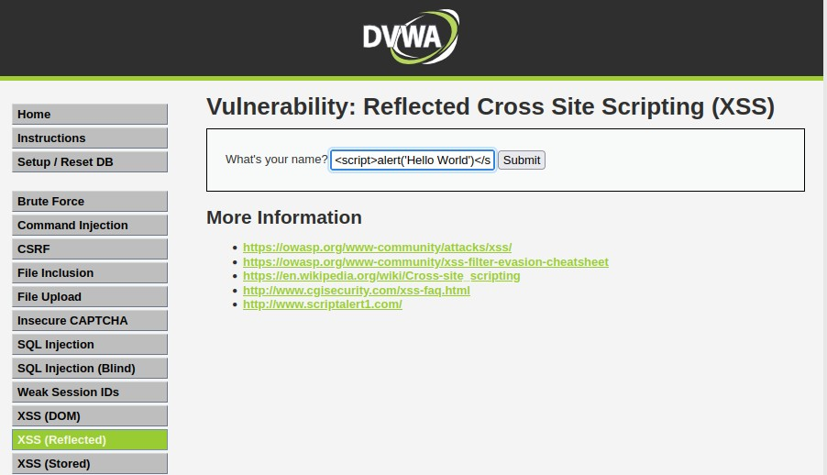
Now instead of any text let’s try some script text.

Ex: <script>alert('Hello World')</script>
It displays an alert as shown below

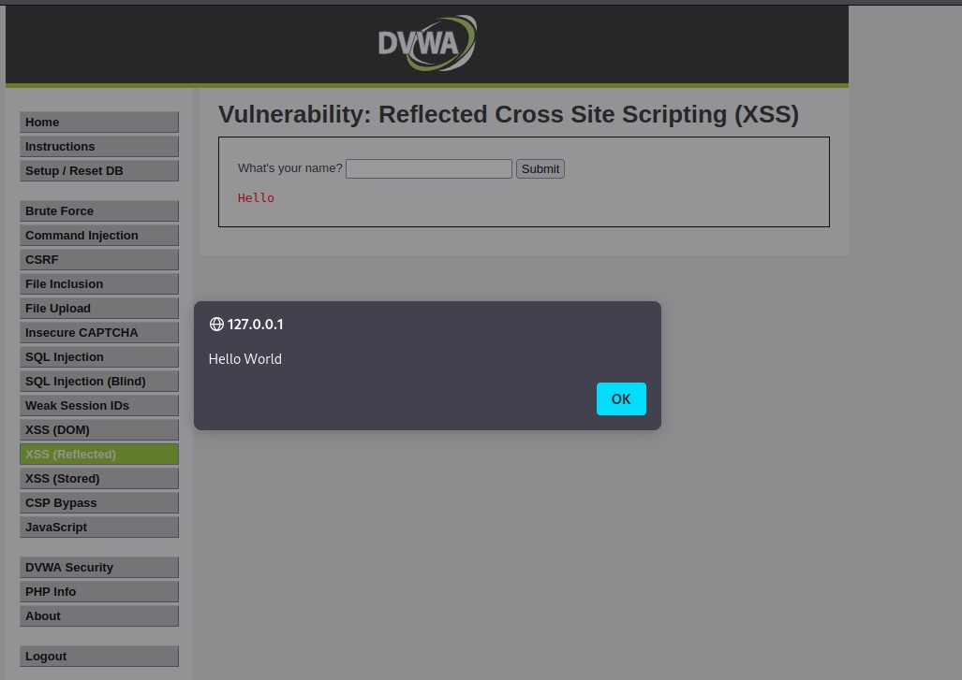

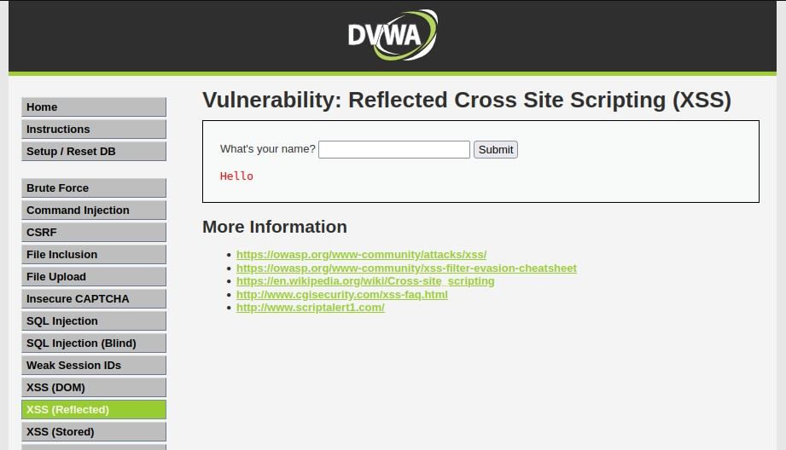
Click Ok

—-------------------------------------------------CSRF ATTACK—---------------------------------------------------

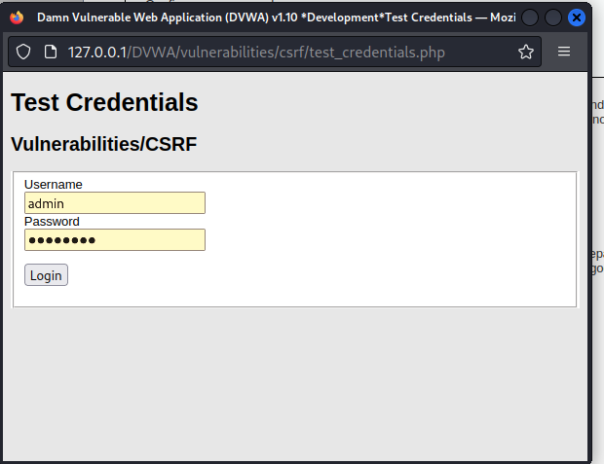
try with pablo
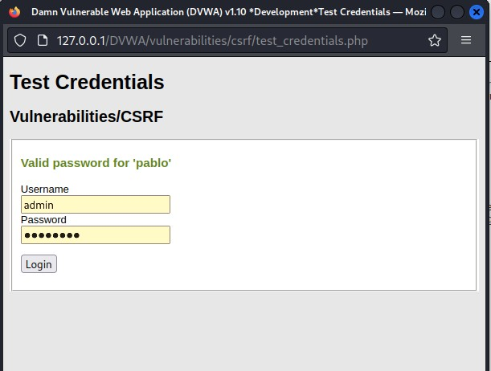

open burpsuite

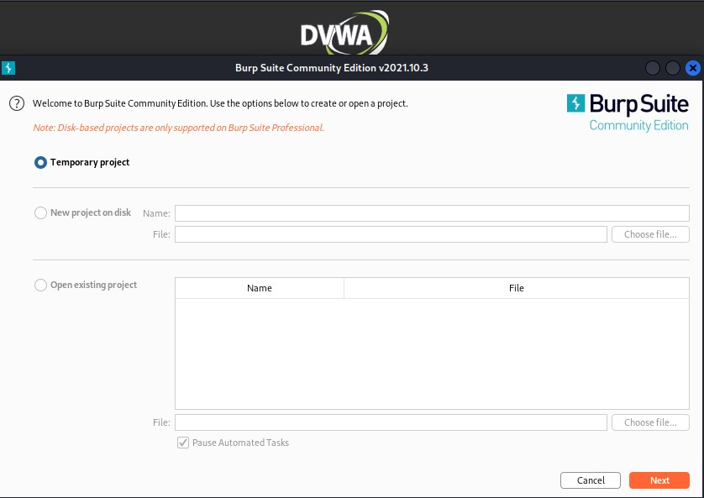

click start burp suite
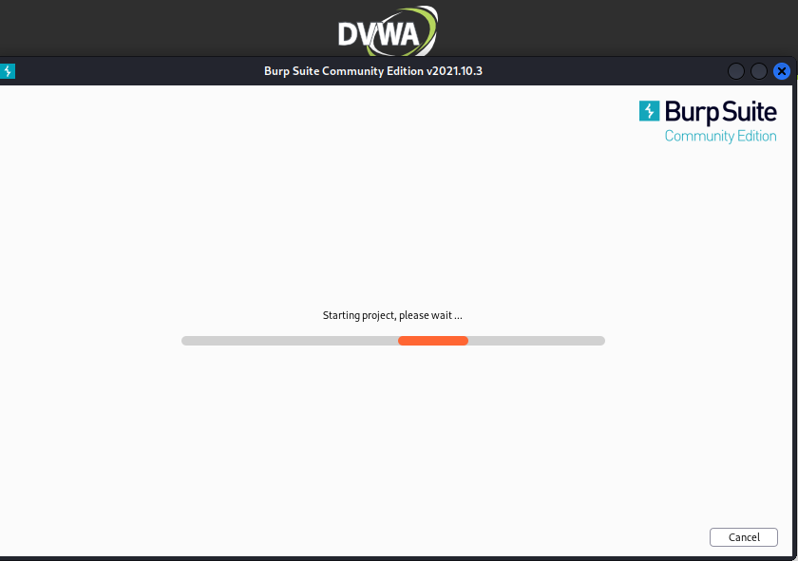

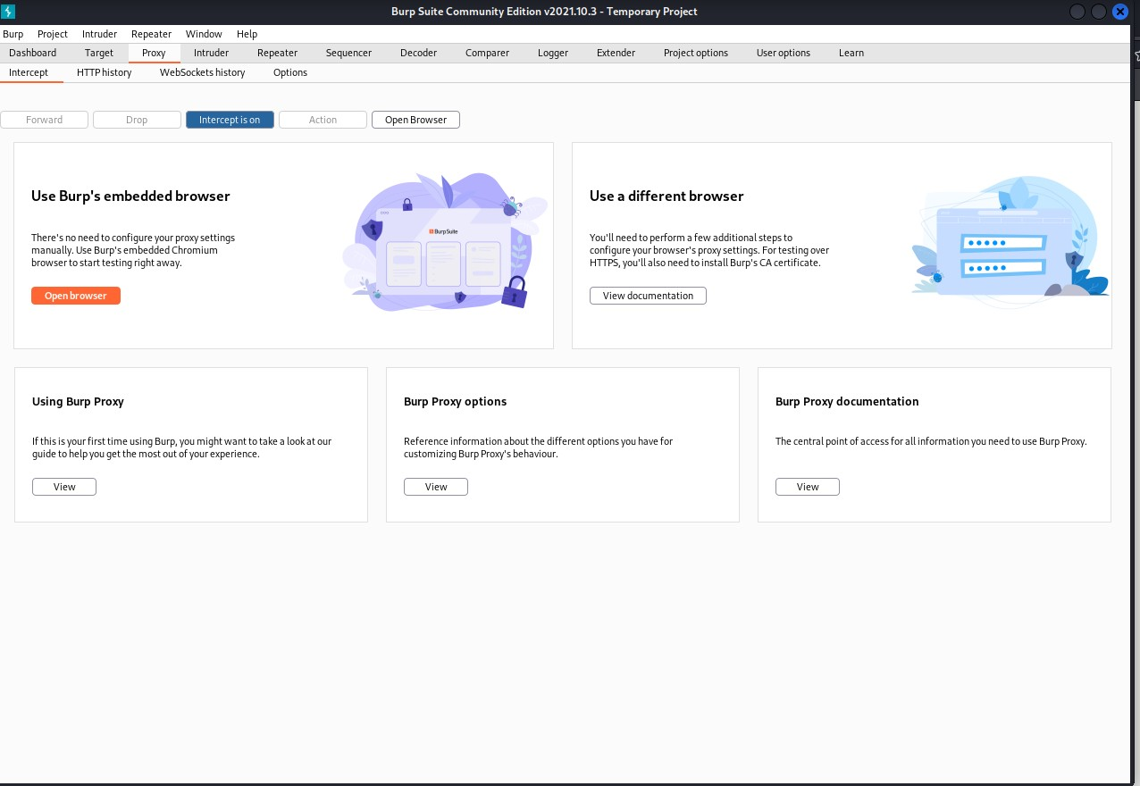

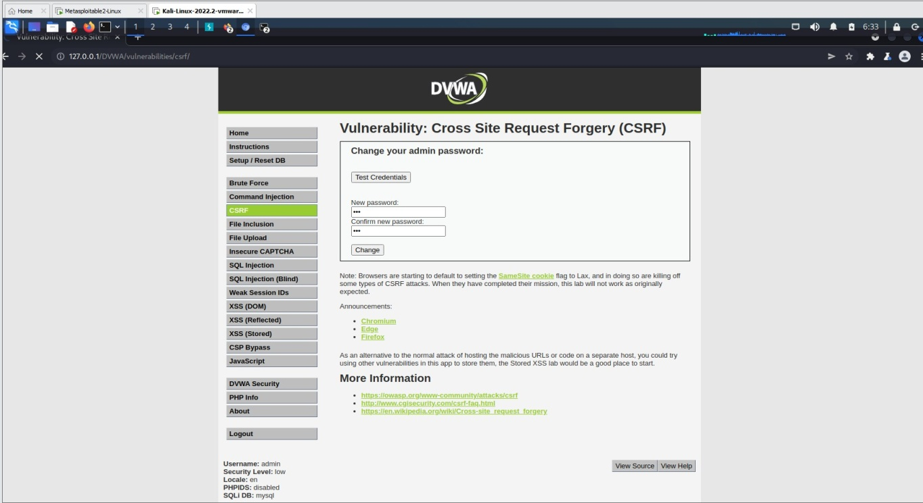
open browser search for

DVWA
http://127.0.0.1/DVWA/vulnerabilities/csrf/?password_new=new&password_conf=new&Change=Chang e
login after inception is on
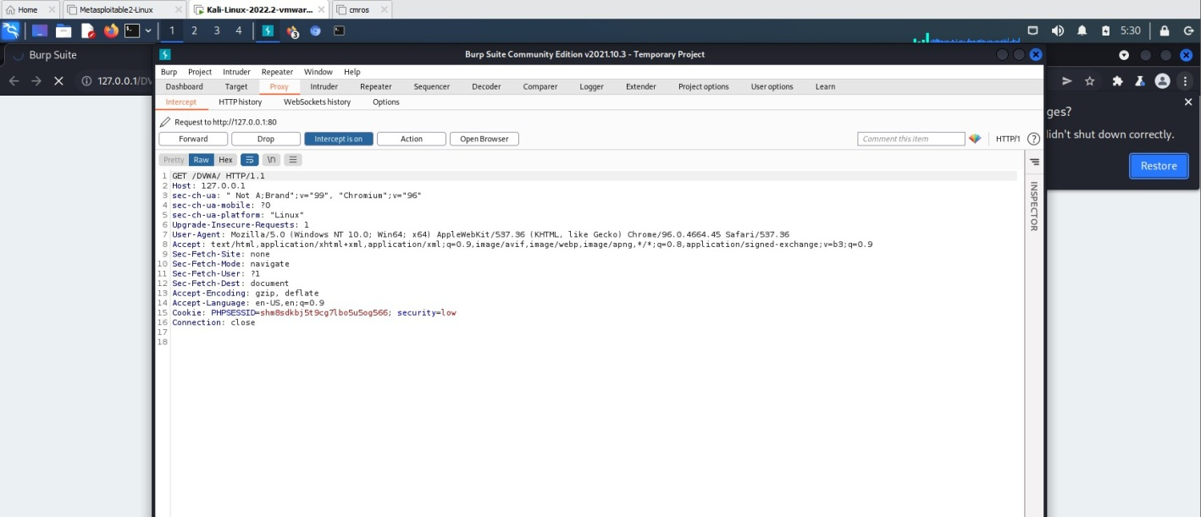
Go to browser using burp suite and Search 127.0.0.1/DVWA

Experiment 5: Implement a firewall for an organization.
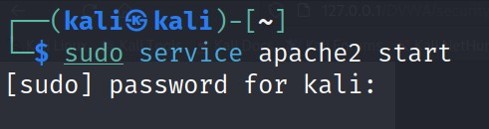
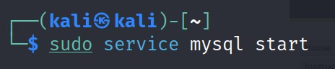

Check ip address in kali
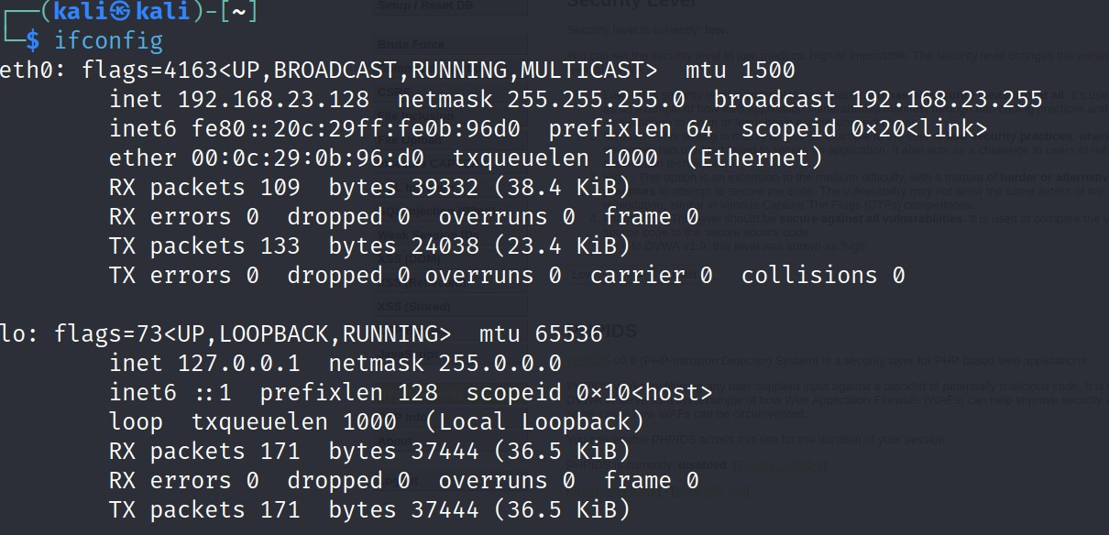
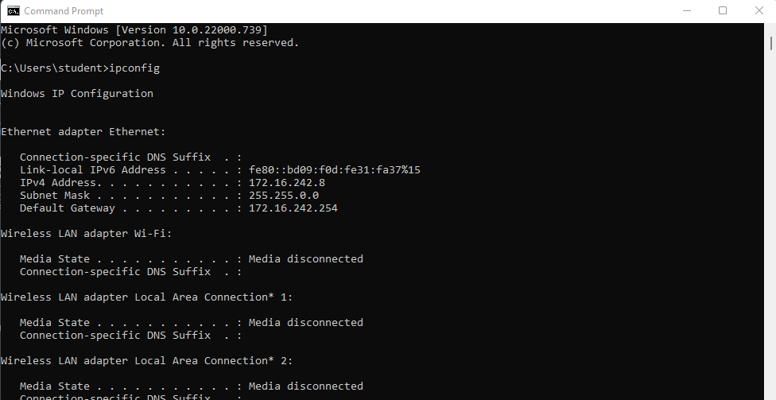
Check ip address for windows in command prompt
Connect windows and kali using command prompt in windows

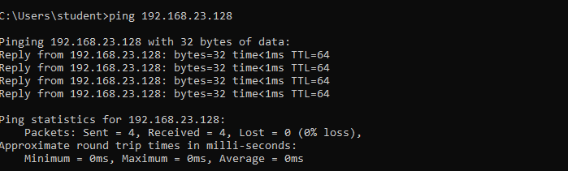
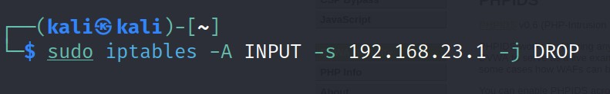
To block pinging of windows system use the following command(should consider only IP address not ethernet’s address)
Now check whether ping requests are allowed in windows
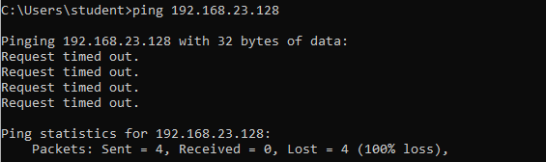
This way we can block ping packets.

—--------------------------------------------------------------------------------------------------------------------------
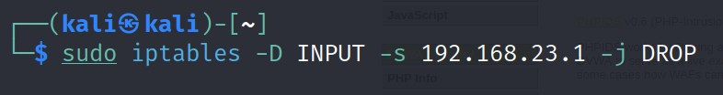
To unblock the ping packets use the commands
Let’s check its unblocking the ping packets in the windows command prompt

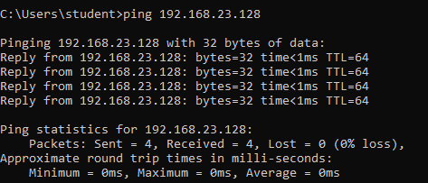
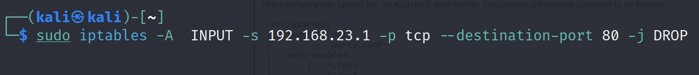
— Task 2: Block the port numbers
Open browser in windows and search for its ip address in the address of kali linux bar – it opens the web page.

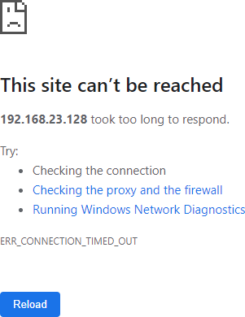

We need to block the availability of port 80. Instead of -A use -D

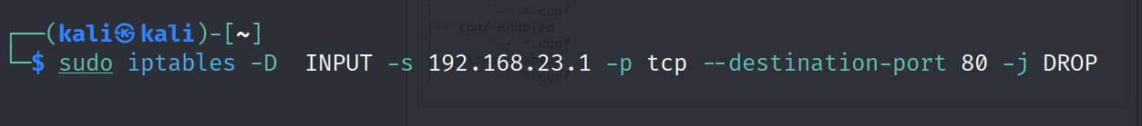

Now check the ip address of the kali linux in windows
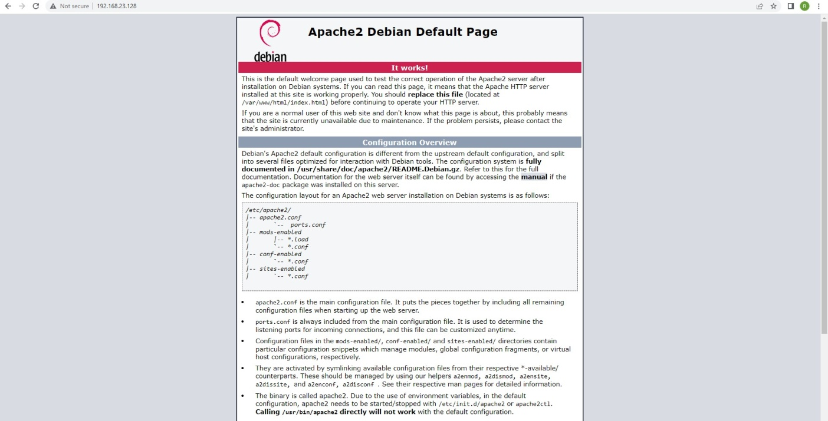

Experiment 6: Implement Wi-Fi security (WPA2, IP based, MAC Based)

Step1: Switch On the D-Link Router.
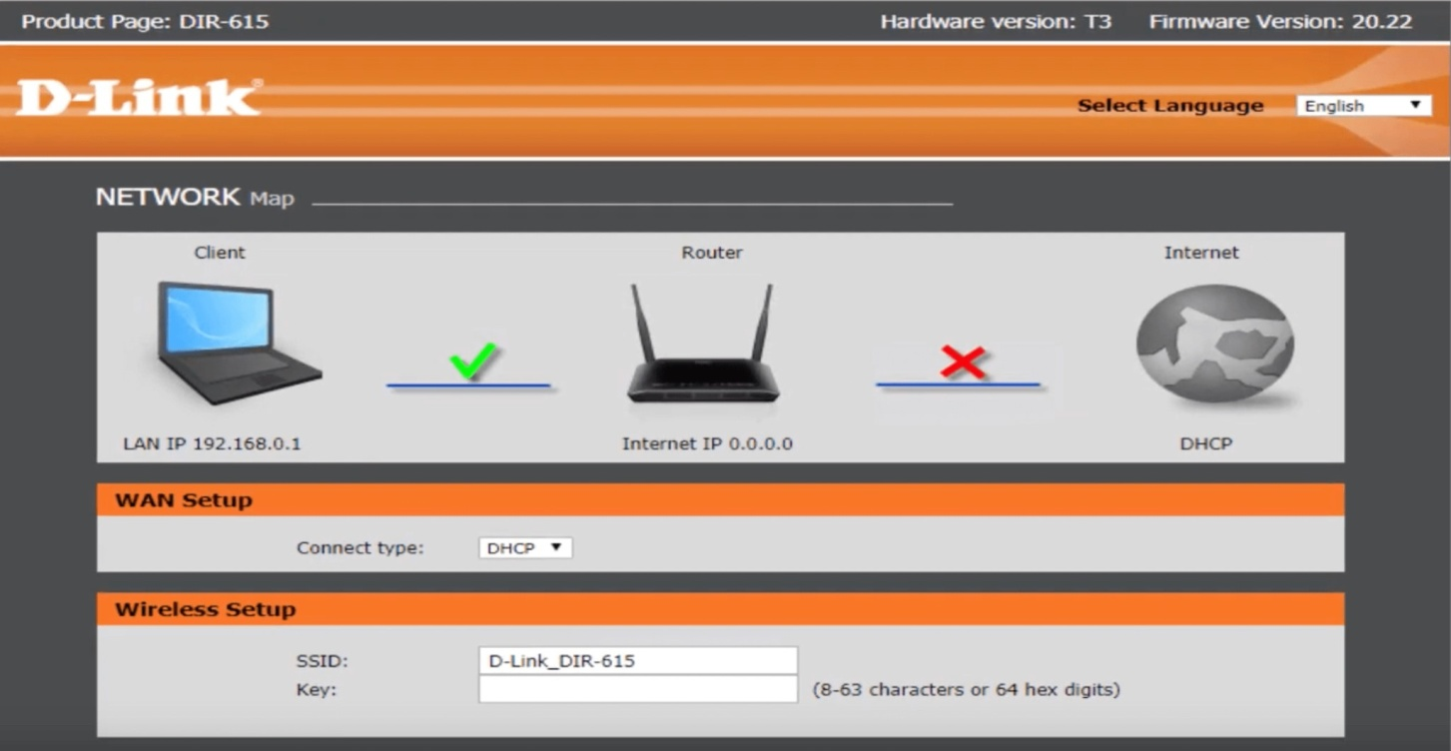
Step2: Open a browser and search for dlinkrouter.local
Login
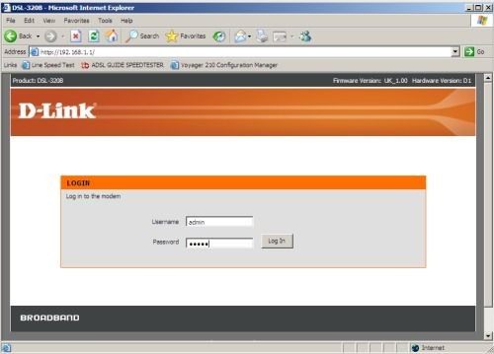

Setup security mode as WPA2

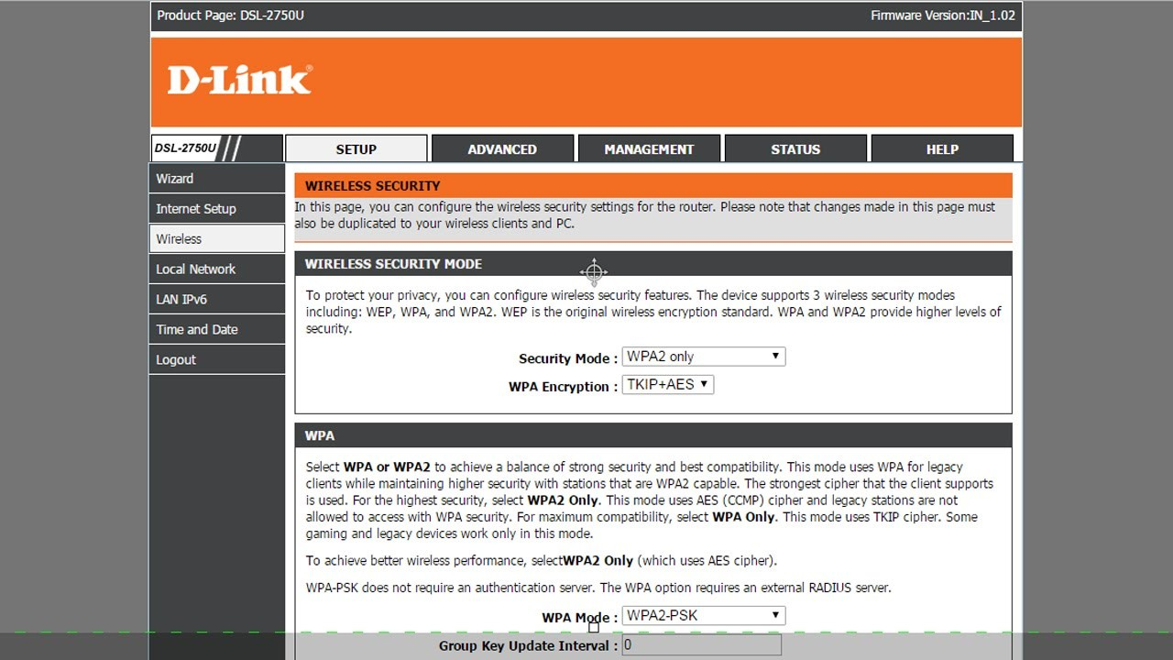
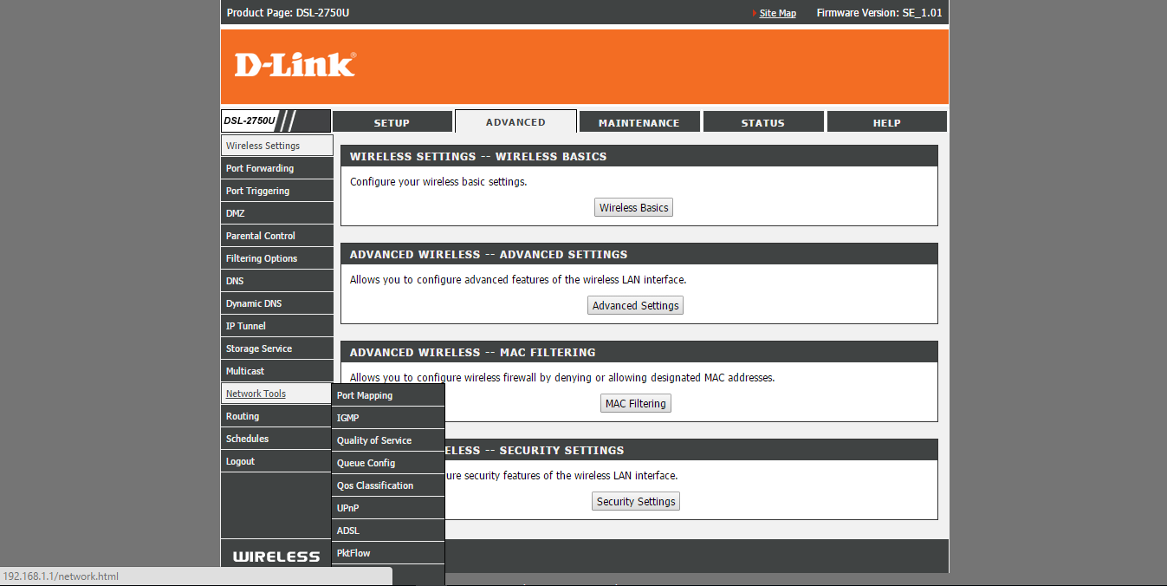
Go to advanced tab

Go to wireless tab

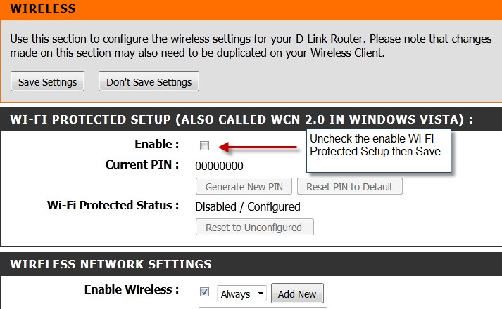
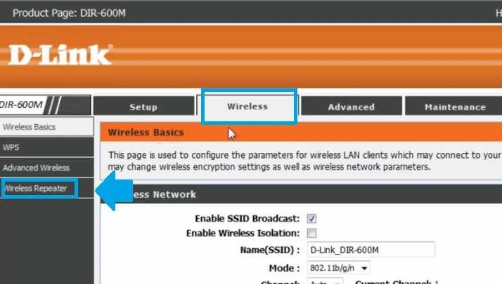
Go to wireless Repeater

Goto status tab

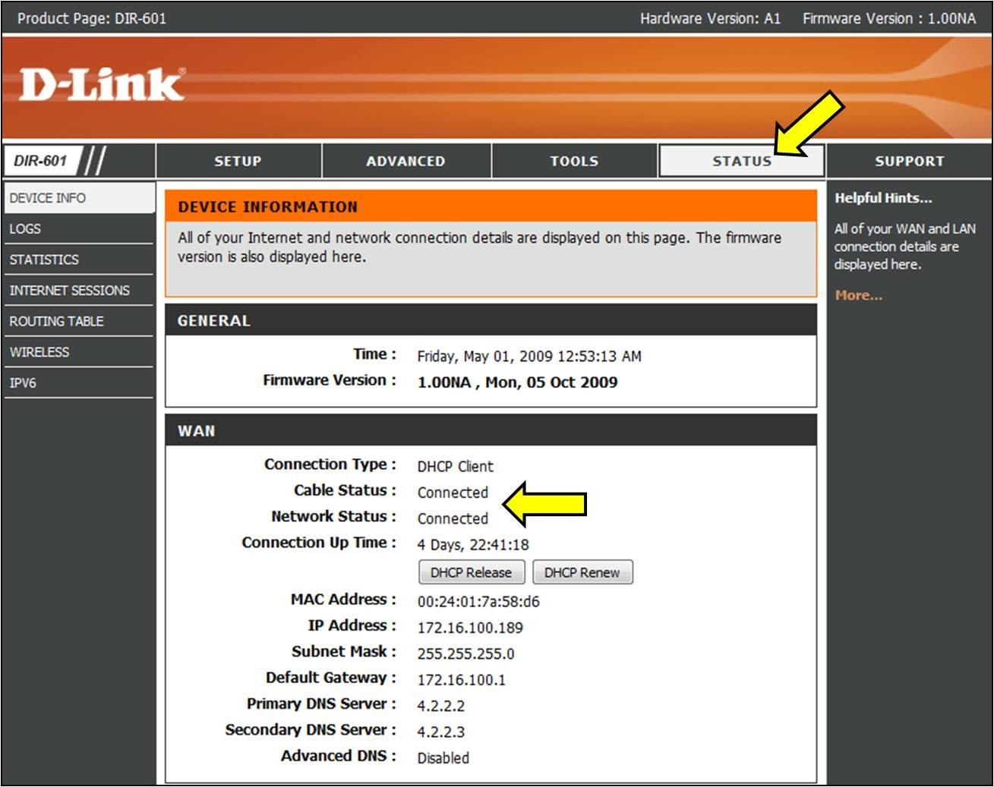

Experiment 7: Analyze and exploit the root system of CMROS

Step1: Download CMROS.zip and extract the zip file. Step2: Open VMWare.
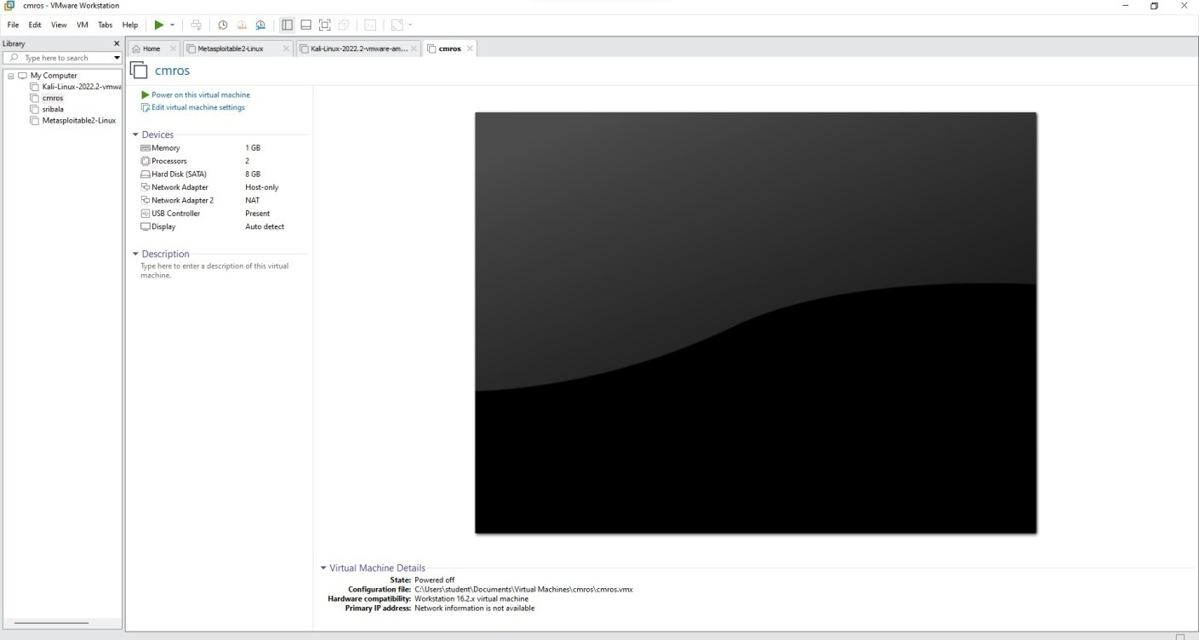
Step3: Open Virtual Machine and click CMROS extracted folder Select the .ovf file
Step4: Power on the cmros virtual machine and consider IP address of cmros
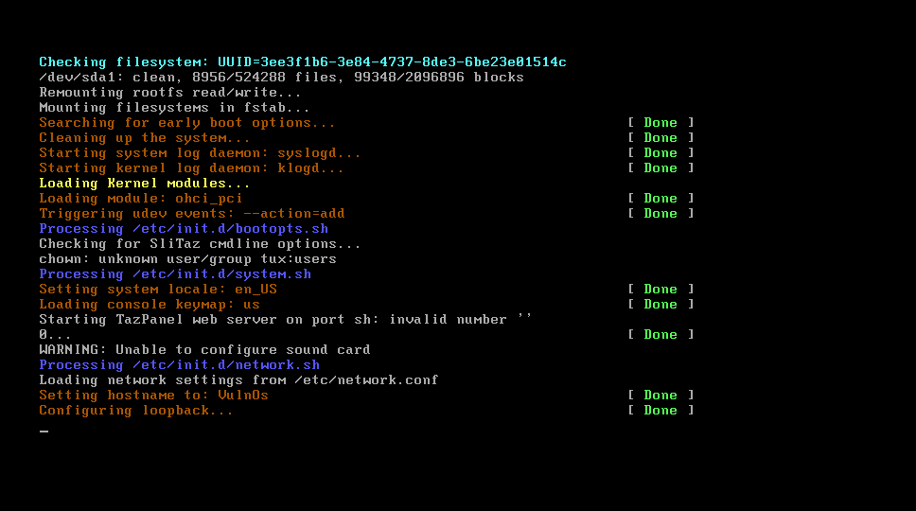

Step5: Open Kali linux on and open terminal

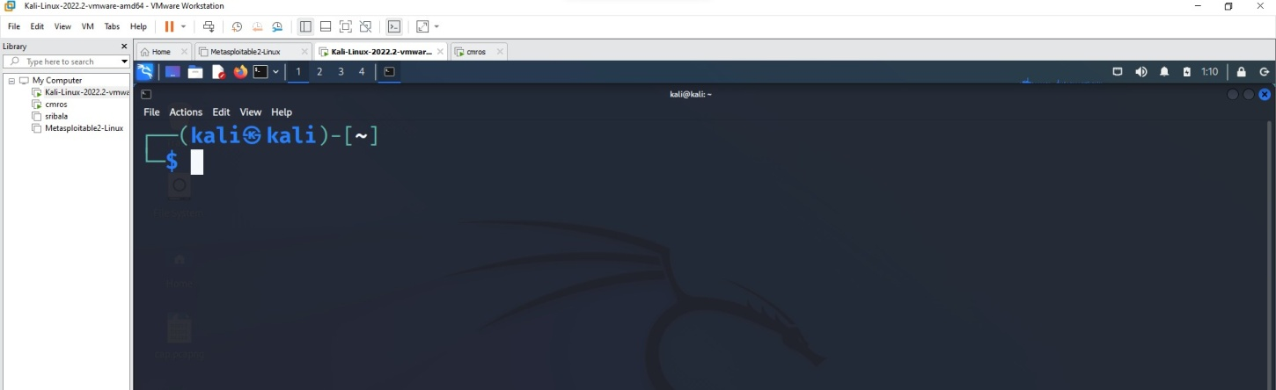

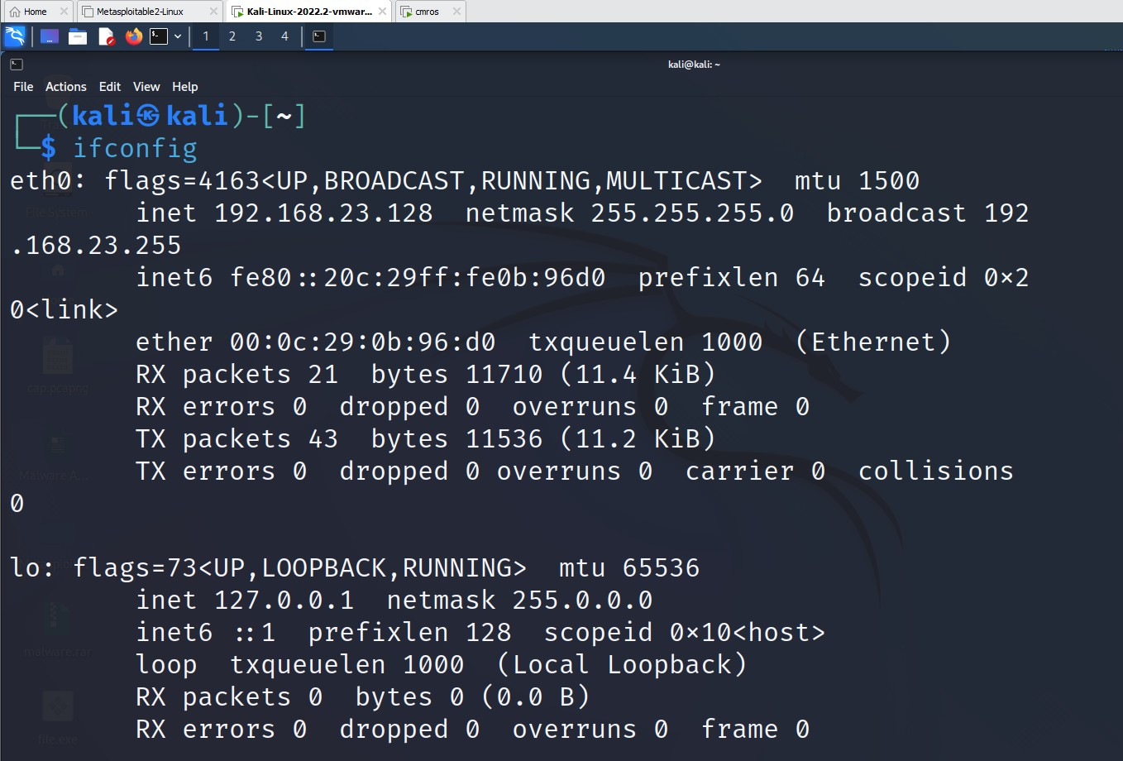
Step6: Start attacking by following commands.

Open nmap tool and give the IP address of the CMROS. It shows only http service only in the nmap tool.

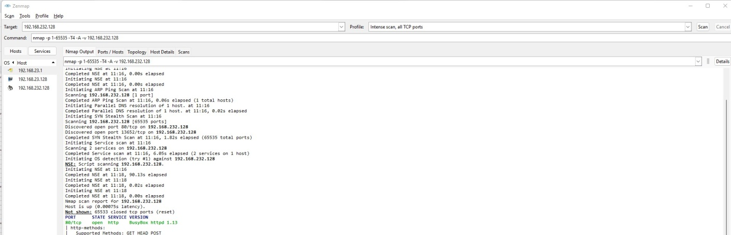
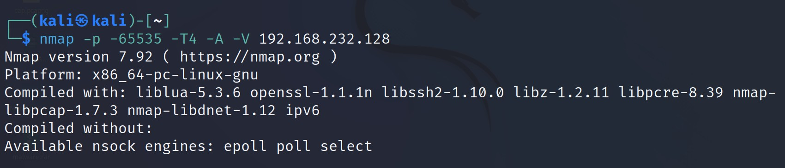
Now use the command below in the kali linux terminal
Now open again nmap tool and set intense scan, all tcp ports
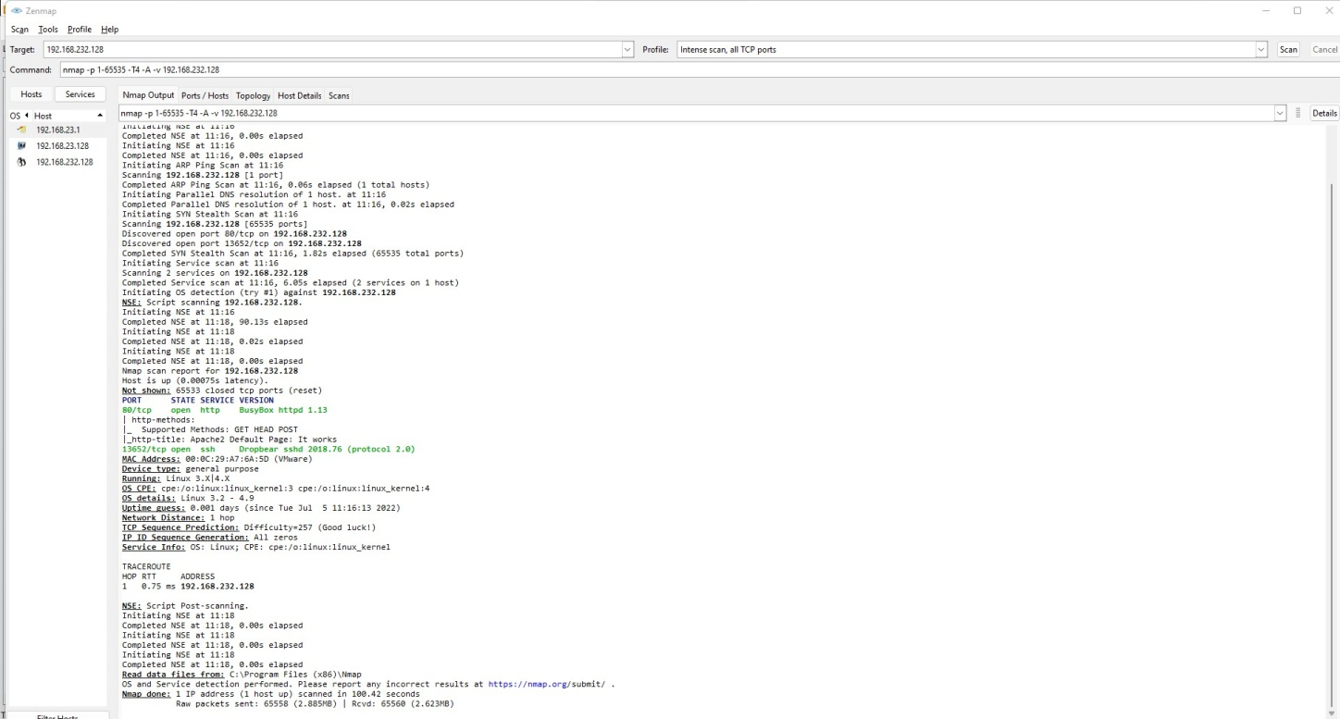
→ Now it displays all ports like http and ssh.

Now open Kali Linux browser and search 192.168.232.128/(cmros ip address)
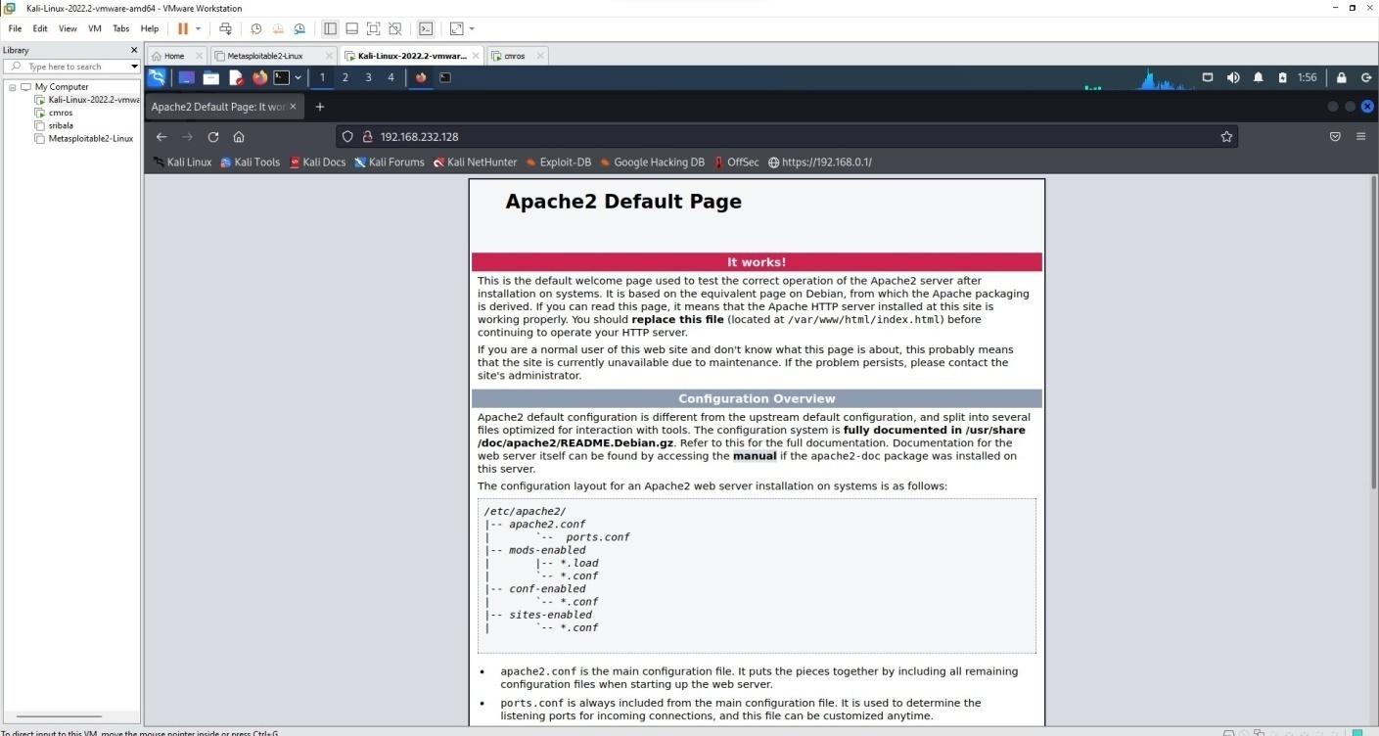
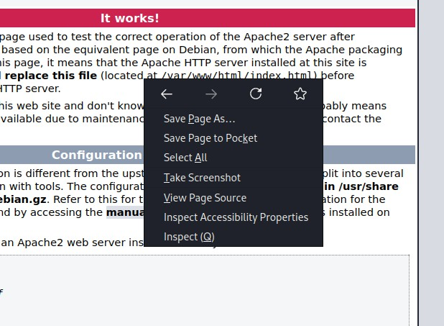
Right click → view page source

It displays the source code

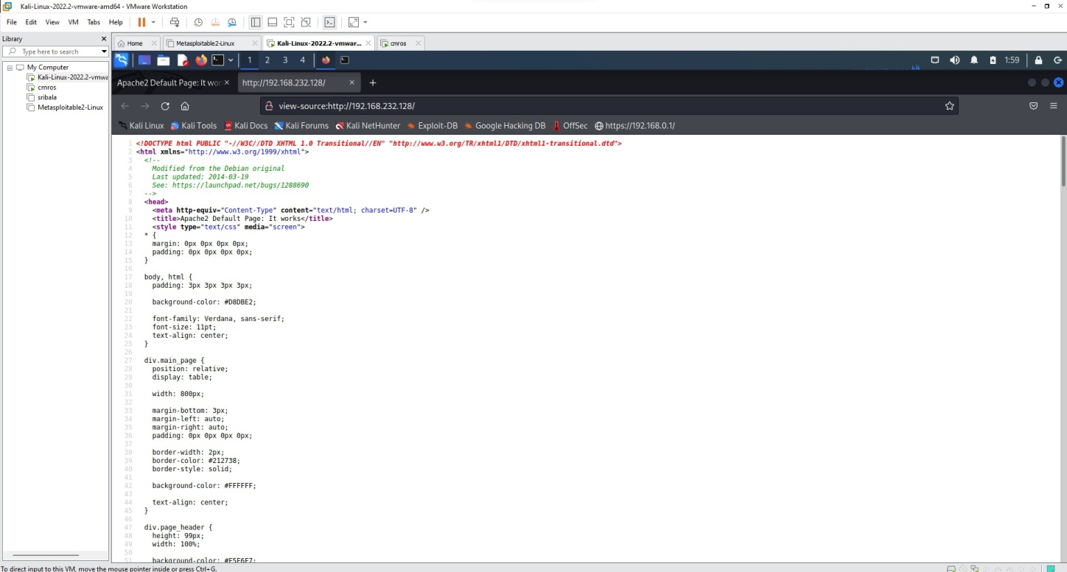

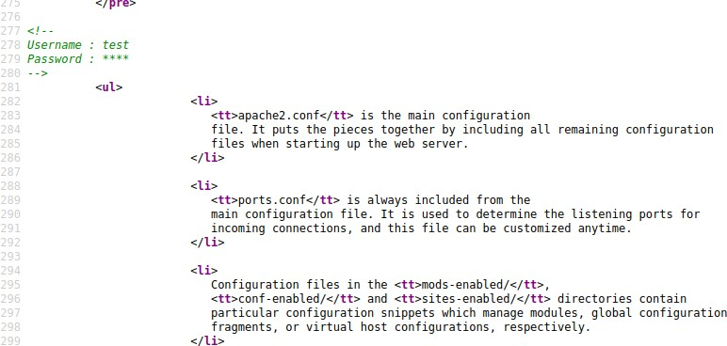
After scrolling down the source code page there we can find username and password

Goto kali linux terminal and use the below command
Use the password we got from the view page source code which is test
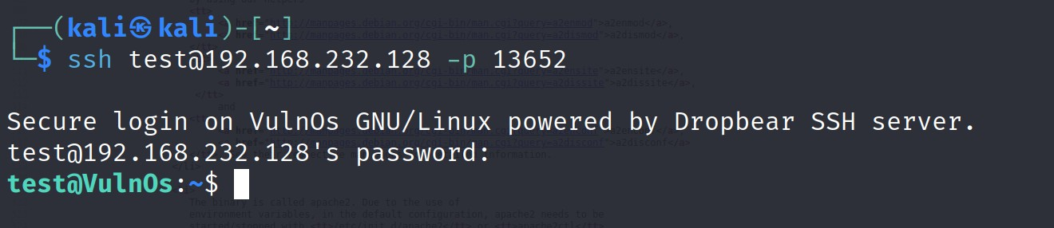

Use ls command

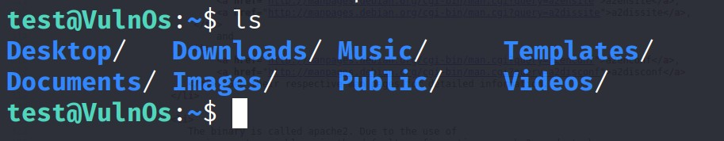
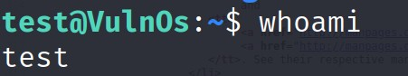
Use whoami to find the user
To know the suspicious file redirect to Desktop and the use ls command
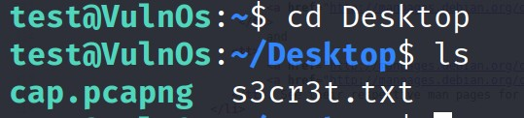
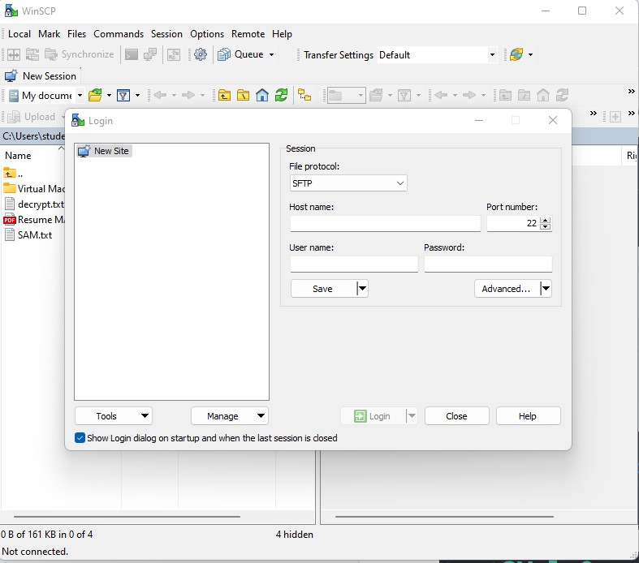
Now go to Windows system, open browser and download WinSCP

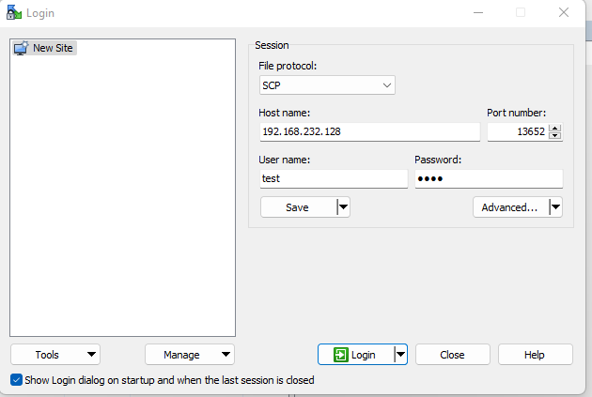
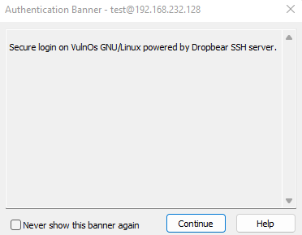

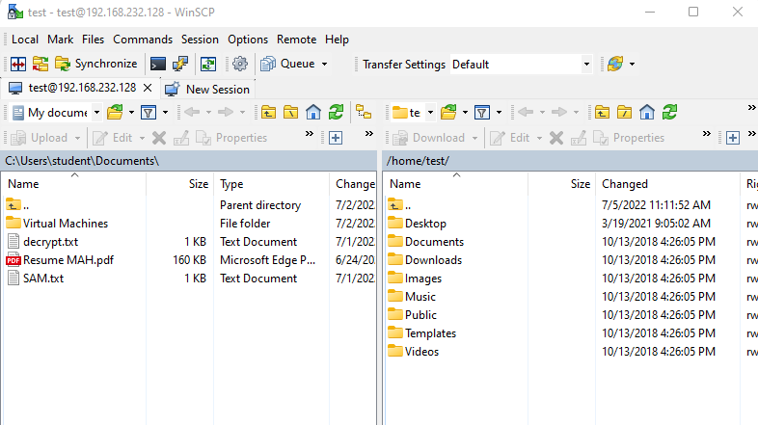

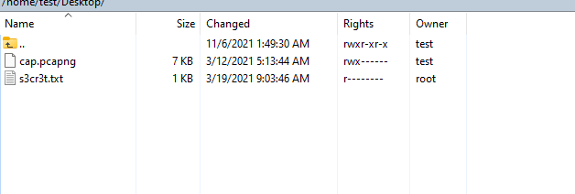
Goto Desktop

Open kali linux and search for wireshark tool

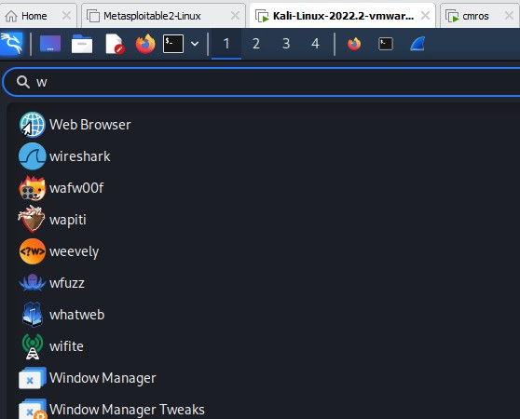
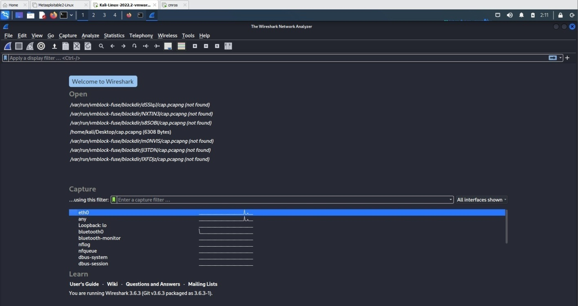
Open wireshark tool in kali
Open cap.pcapng file in the wireshark from desktop folder

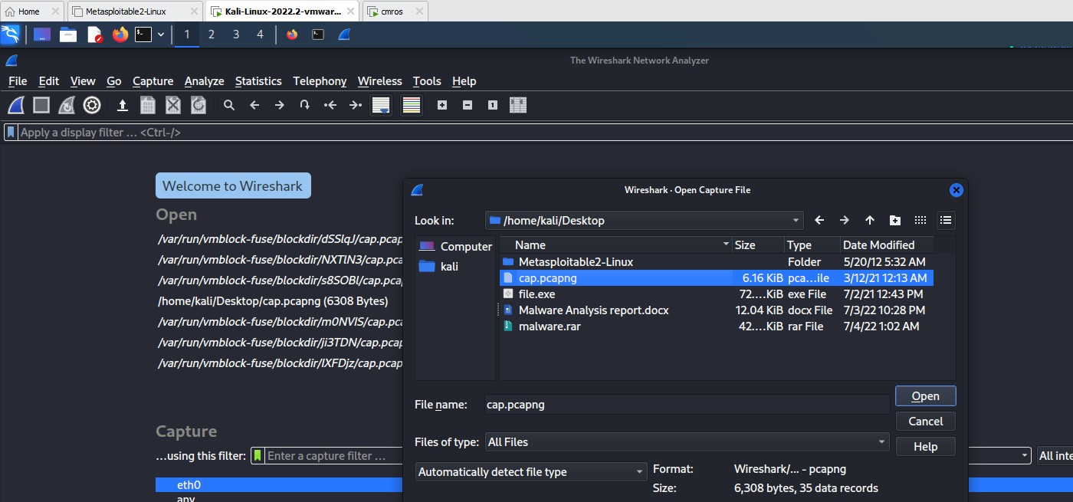
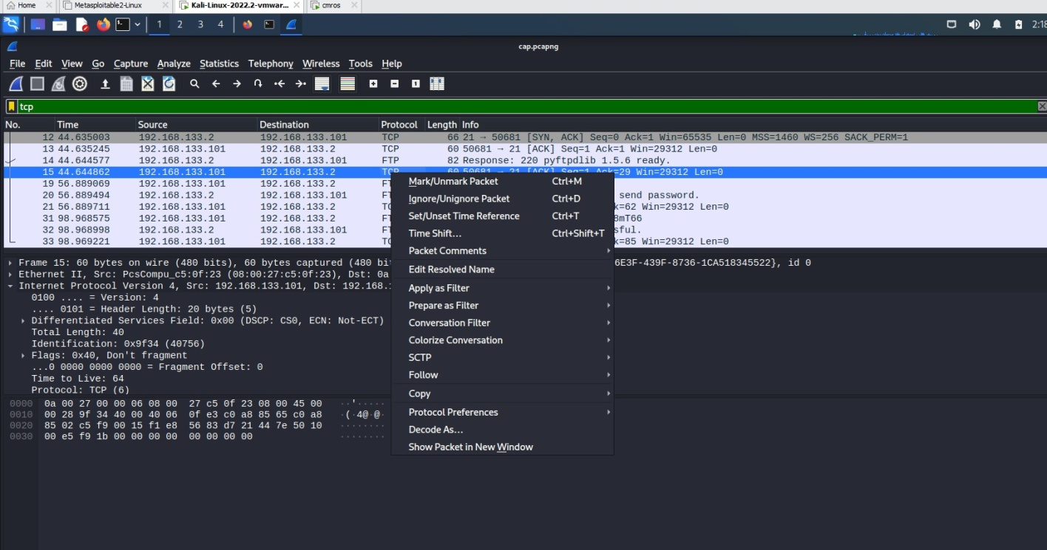
Click any tcp filter and then right click →click follow → TCP Stream
It displays user credentials

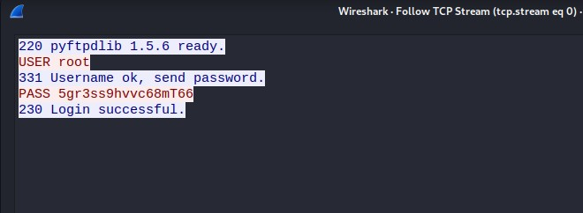
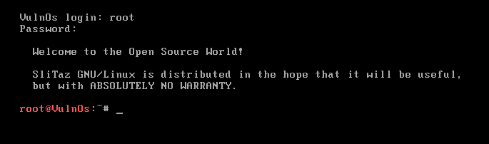
Now copy password and open cmros using above credentials By using the above credentials we can crack cmros system
Now use ls command root@VulnOs:~# ls Desktop tazinst.conf
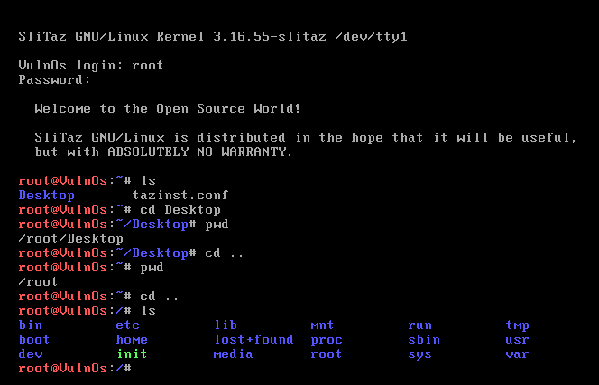
root@VulnOs:~# cd Desktop root@VulnOs:~/Desktop# ls

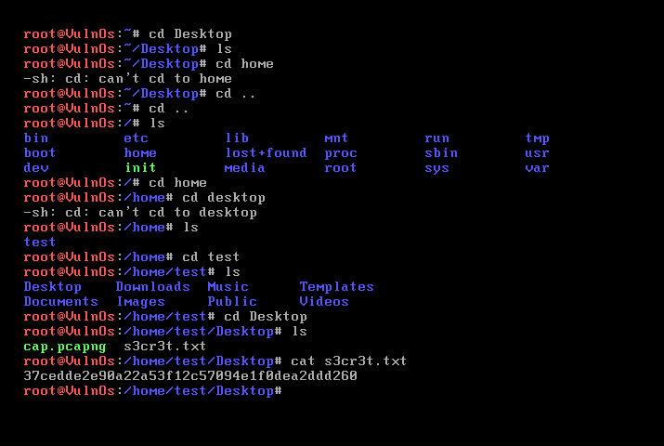

Experiment 8: Implementing and analyzing target using metasploit and gain control over the system

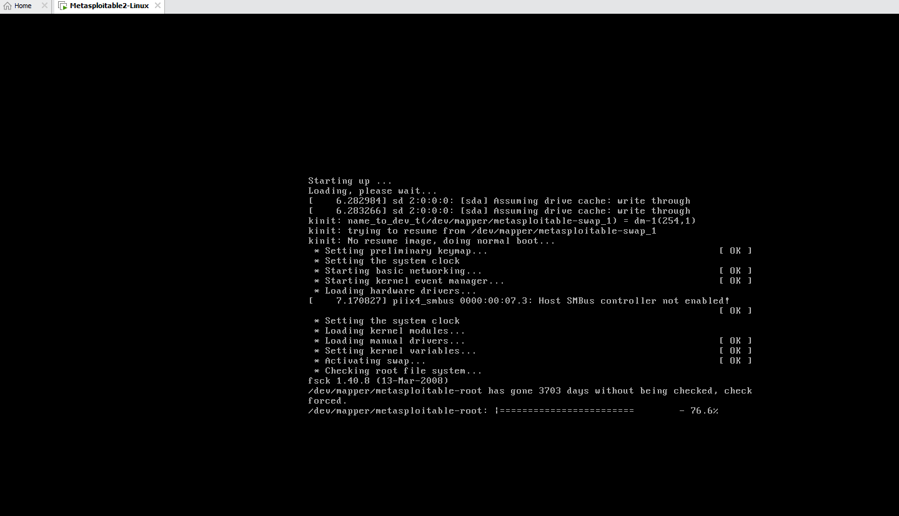
Open metasploit in the virtual machine and power on
username and password is same msfadmin
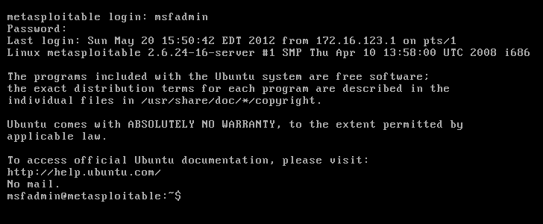
If there is no zenmap tool you can use Quick scan in kali linux Nmap -v -A 192.168.23.129(metasploit ip address)
If nmap is installed in the system

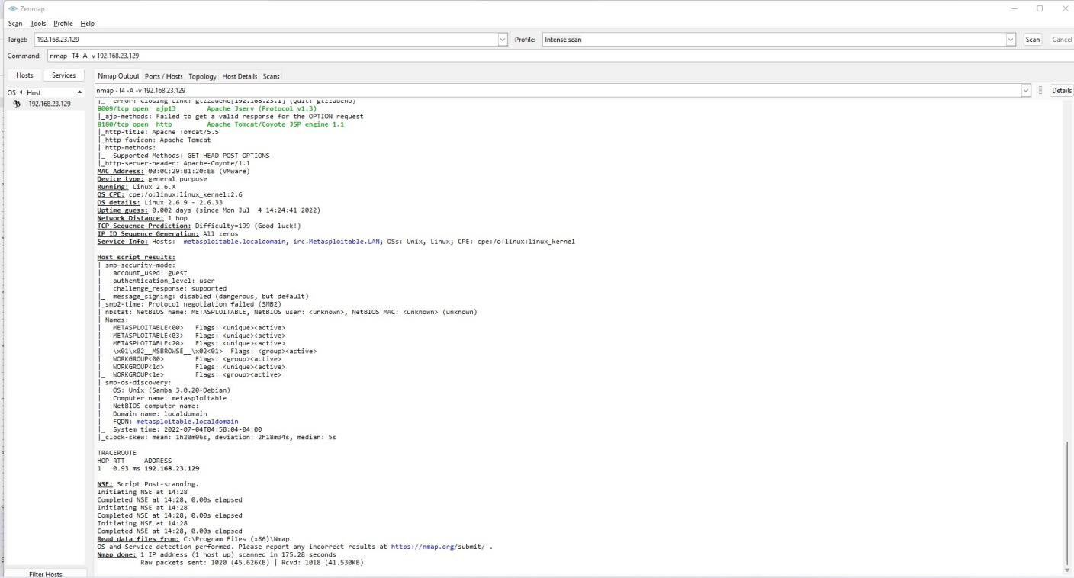
If we wanna port 21

21/tcp open ftp vsftpd 2.3.4

|_ftp-anon: Anonymous FTP login allowed (FTP code 230)

| ftp-syst:

| STAT:

| FTP server status:

| Connected to 192.168.23.1

| Logged in as ftp

| TYPE: ASCII

| No session bandwidth limit

| Session timeout in seconds is 300

| Control connection is plain text

| Data connections will be plain text
| vsFTPd 2.3.4 - secure, fast, stable

|_End of status

Attack on this port 21 if you know the version of the service, just goto browser and search for the version. To find whether the service version is having any vulnerability.

To exploit we can use metasploit
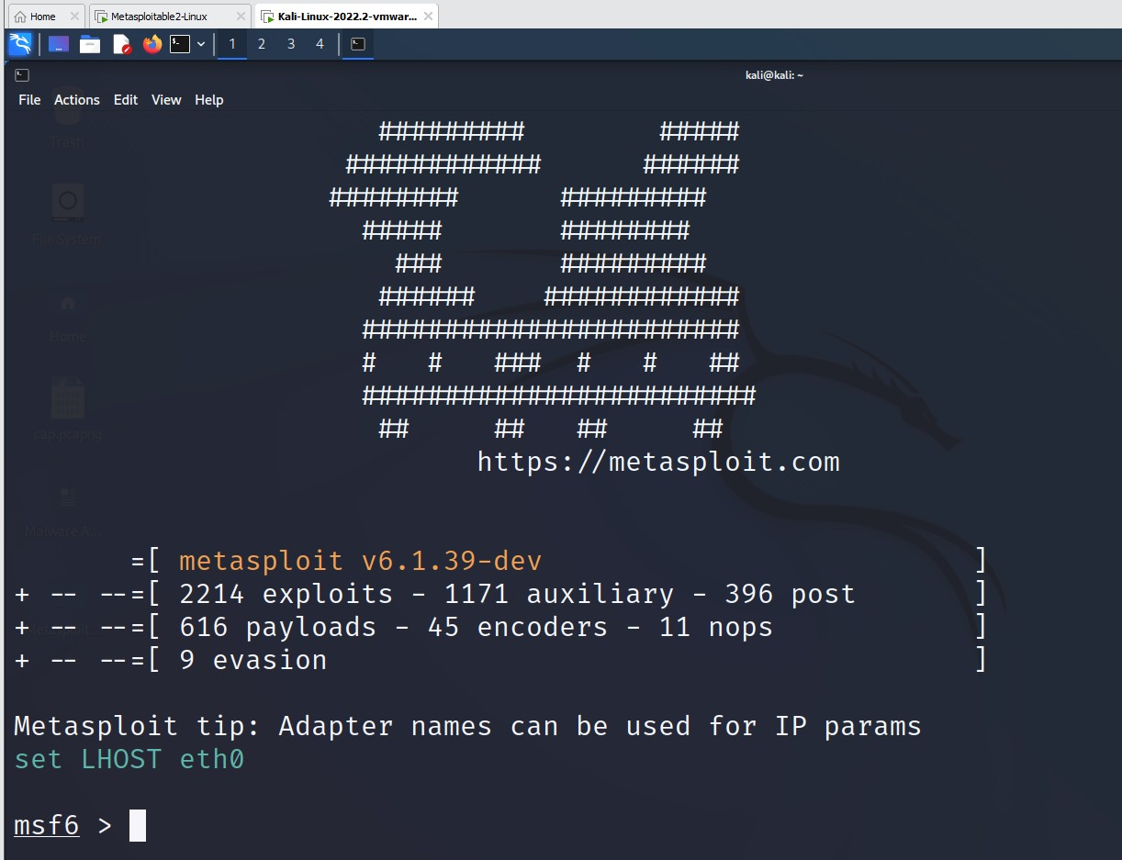
Goto kali machine open terminal and type msfconsole
It displays no op exploits for the system.. To know the exploit of that service version
To find the name of the exploit – search vsftpd

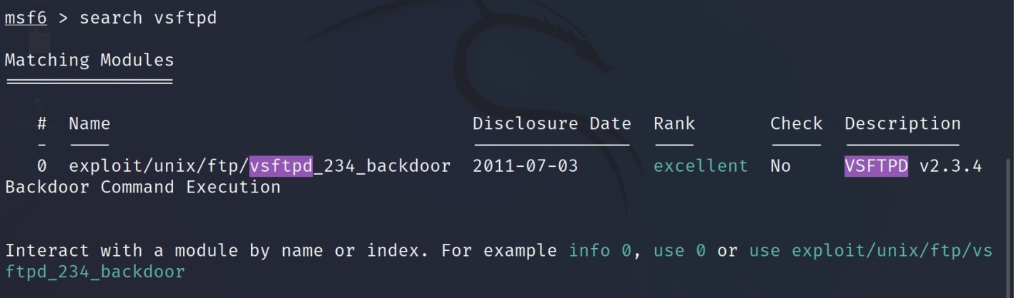
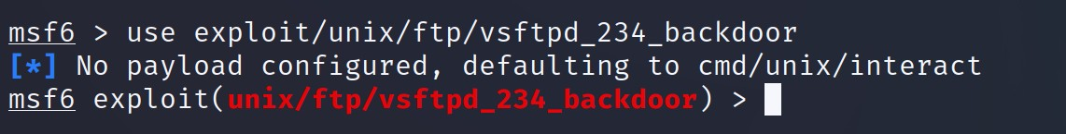
To use the exploit
To know more about the exploit use info
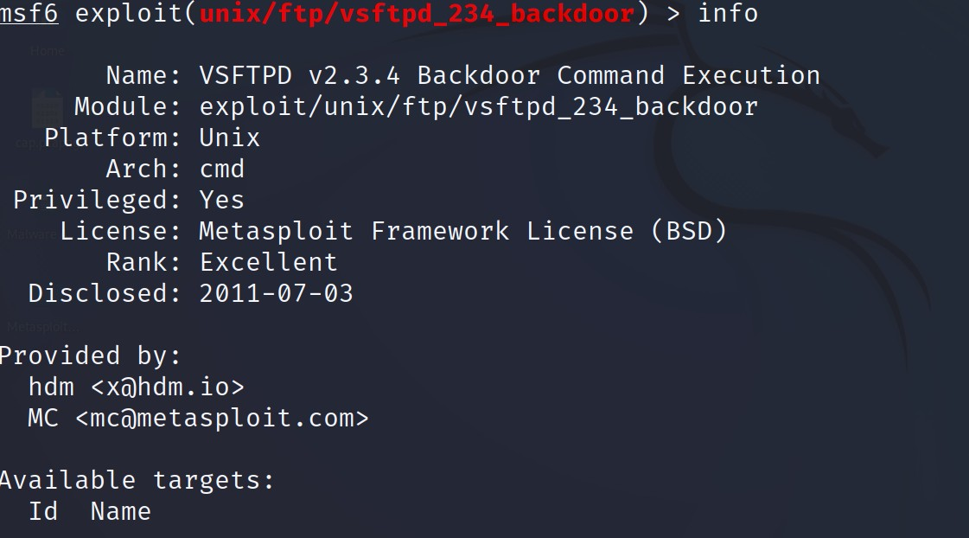

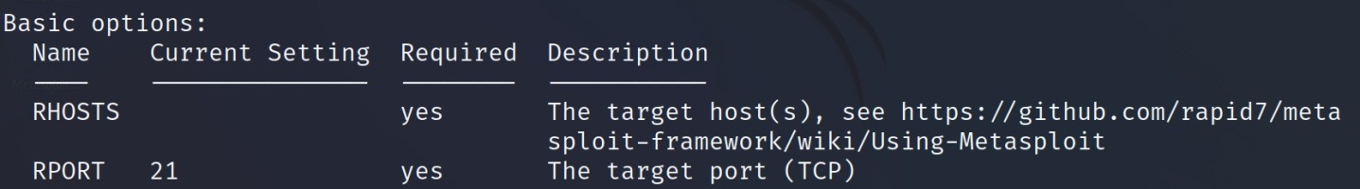
Set rhost ipddress

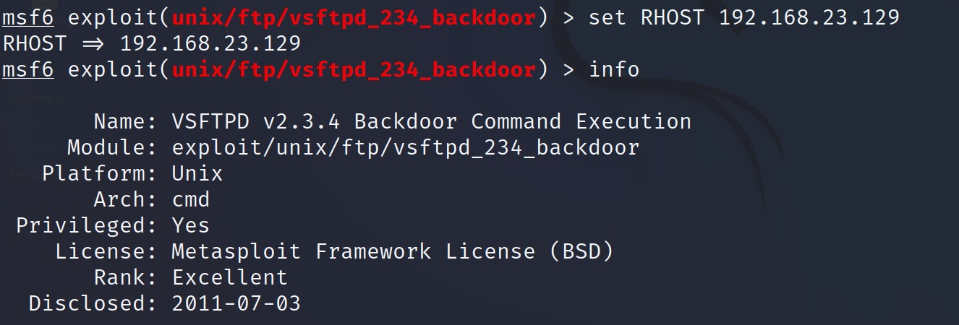
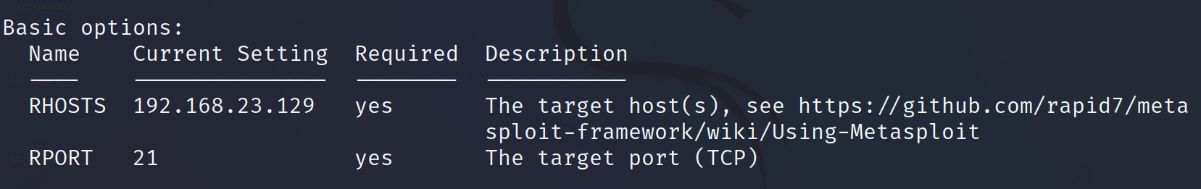
Use info to check RHOST
To take the advantage of the exploit we use payload
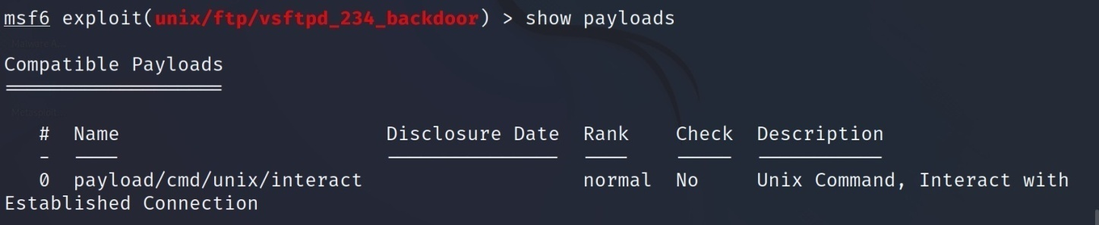
>show payloads
Set the payload
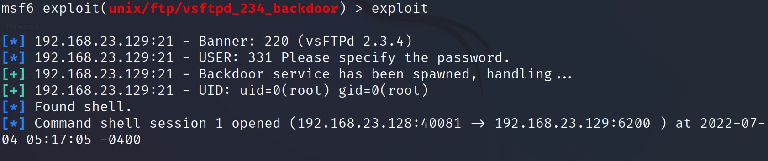
Exploit
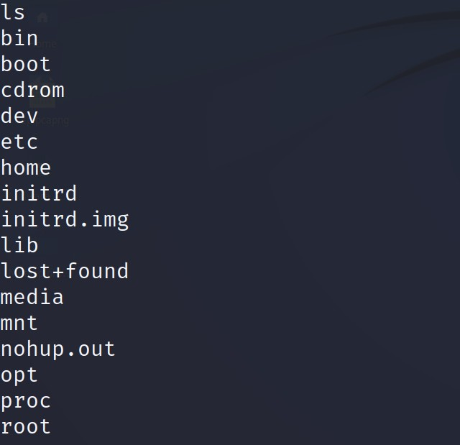
Use linux commands such as ls

Try to find vulnerability for port 445

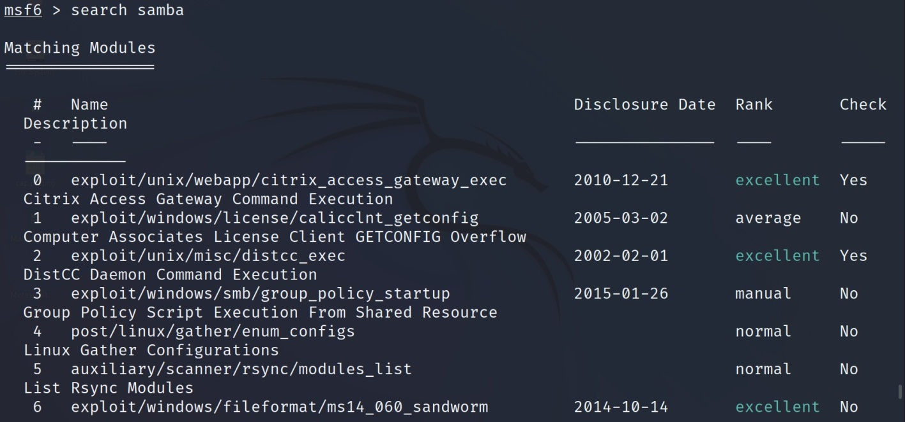
Or

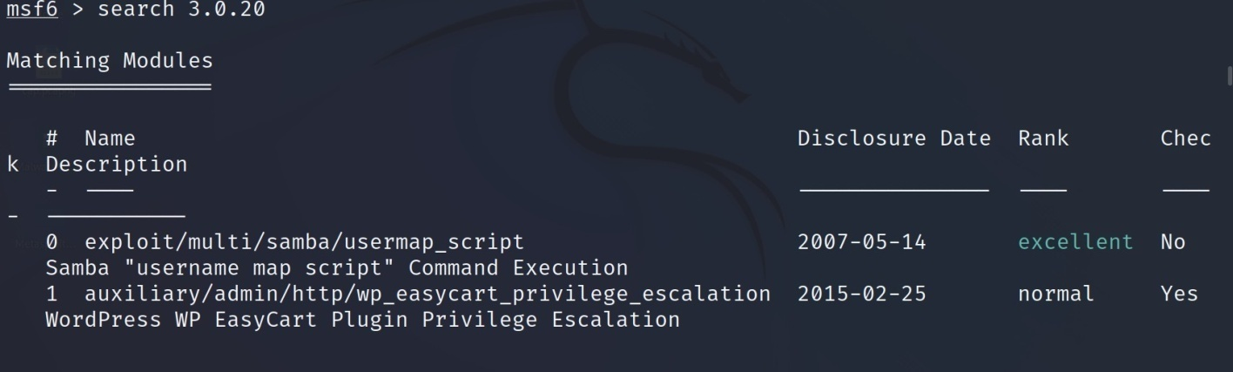
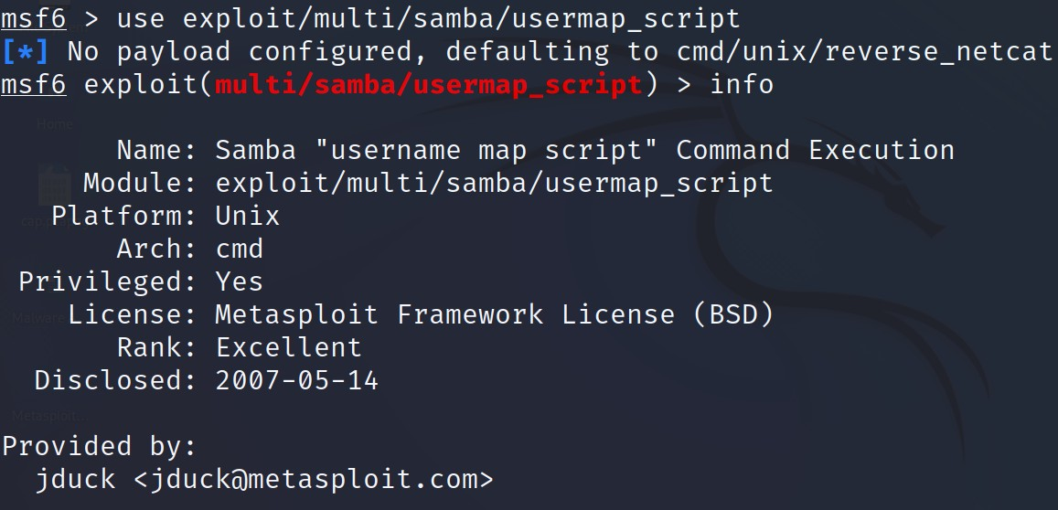
Use exploit
Set RHOST
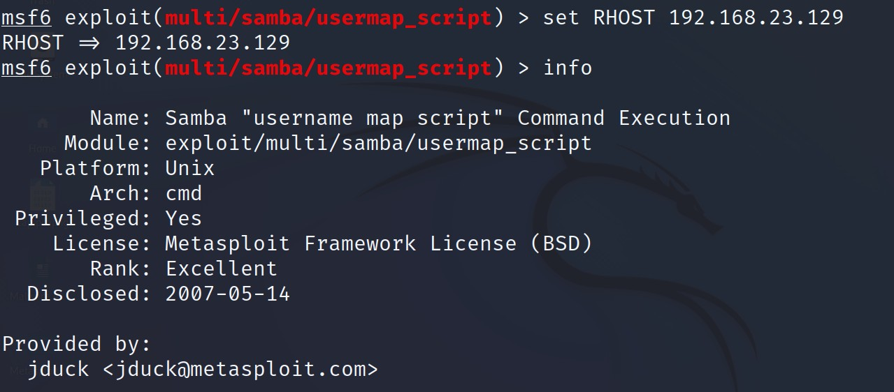
Show payloads

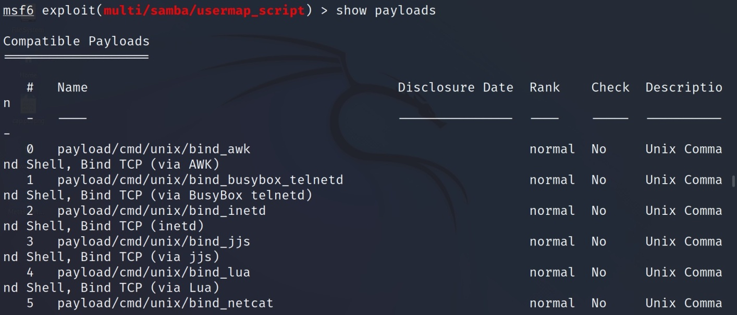
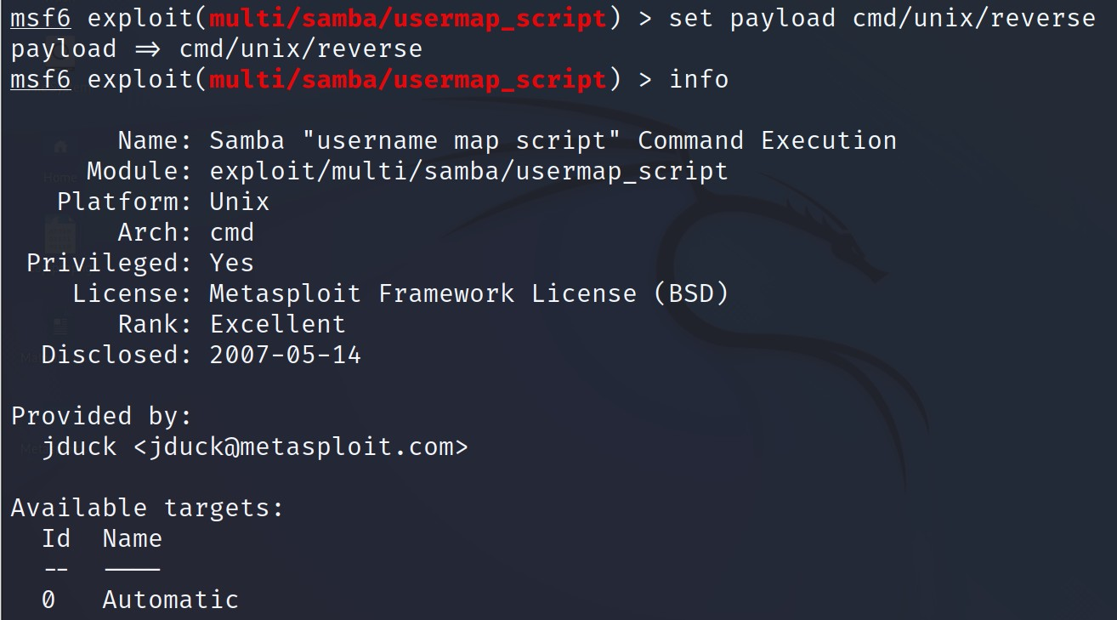
Use payload

Exploit

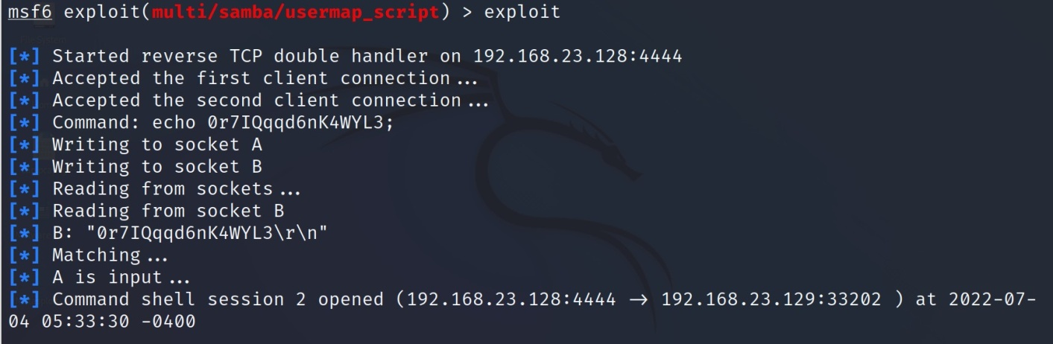
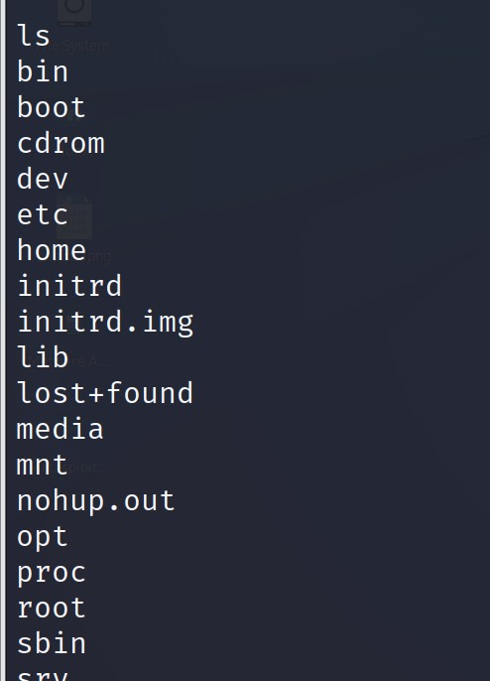
Run some unix commands

Experiment 9: Implementation of IT Audit, malware analysis and Vulnerability assessment and generate the report.

Step1:

Collection Information about Malware:
How a malware is collected.

Step2:
Basic Information about malware:
Name: file.exe
Media Type: application/x-msdownload
SHA-256: d01d08621690c1a7a0f41bdd1bb02ec05d418ef68b06cd3cfd54fbb3f58ba80a Report ID: 37cec6e6-0778-4c35-9cb3-d177c1e6e34a
Submission ID: 62c24f59783441cda10213de Submission Date: 07/04/2022, 02:24:27 Step3:

Report from filescan.io
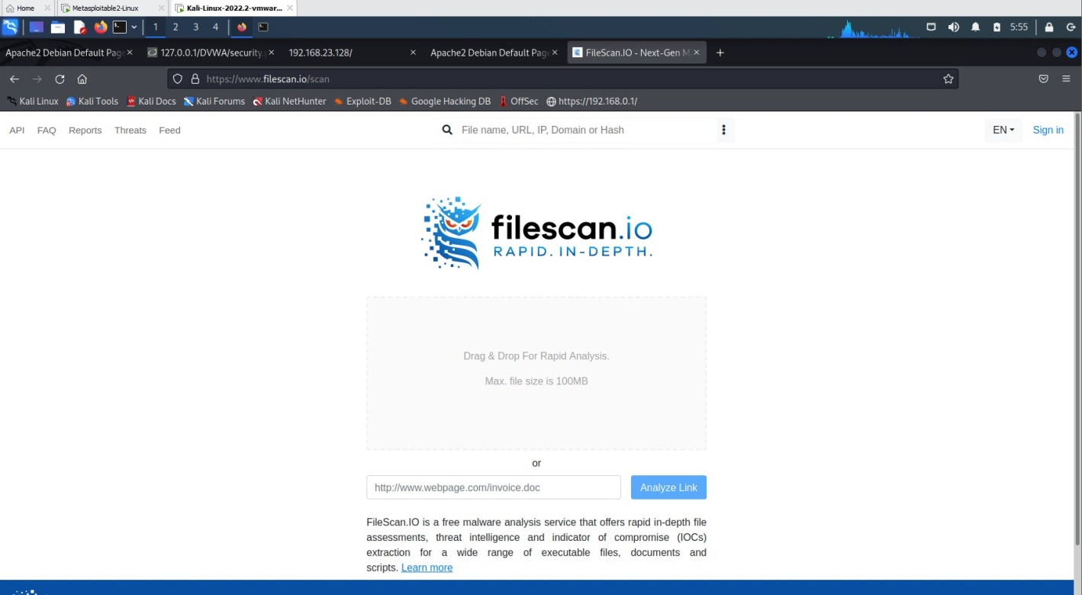
In filescan.io

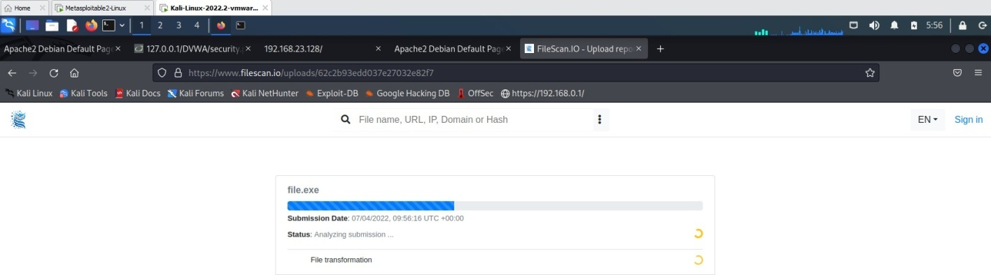

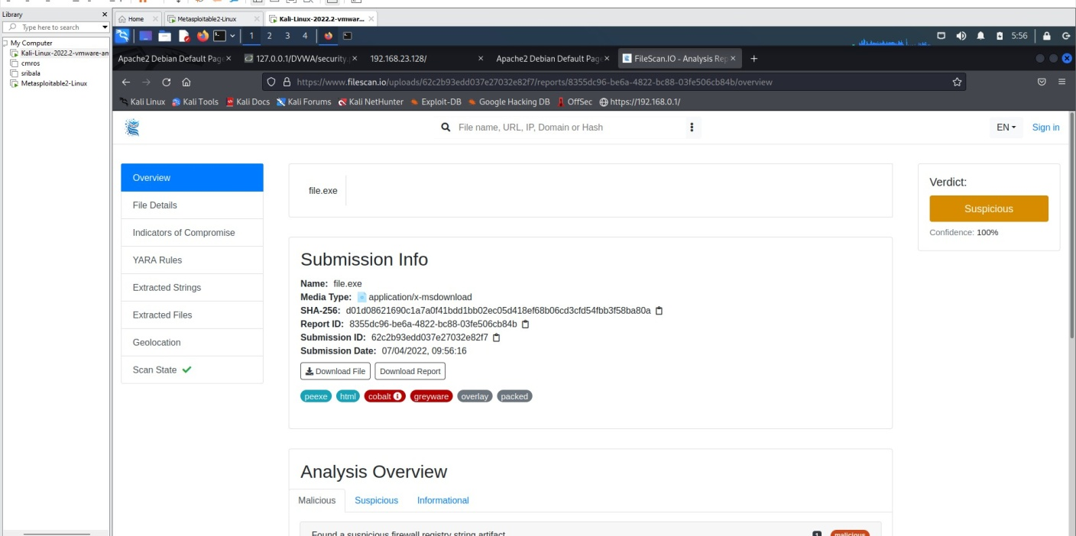

Report in virustotal

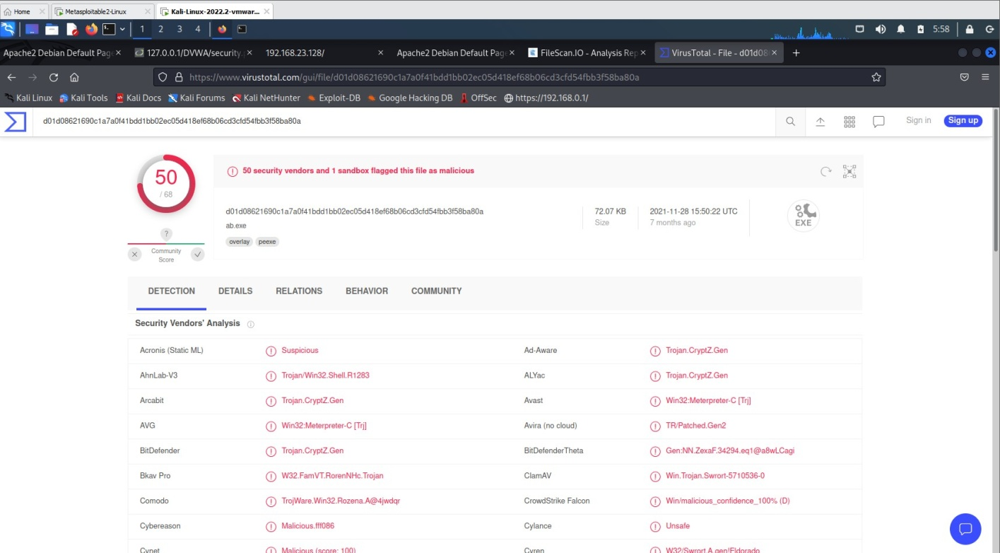

Final deduction

Final report.

IT Audit: Do the port scanning of the computer using nmap/zenmap to identify the open ports and see if services running on those ports are vulnerable or not. Write a report on it. [Note: Clear any firewall rules that you have added by using the command sudo iptables –F]

Experiment 10: Test security of UPI applications on Desktop sharing applications.

Step 1:
Download and install UPI application on your phone
Download and install Teamviewer on your phone and computer Download and install Anydesk on your phone and computer

Step 2:
Test the security of the application and fill the table (keep adding more applications as you test)

List of UPI Apps

UPI Apps Team Viewer Any Desk BHIM
Google Pay

